

Republic of the Philippines

Western Mindanao State University

**COLLEGE OF COMPUTING STUDIES**

DEPARTMENT OF INFORMATION TECHNOLOGY

**WMSU PALARO CONTENT MANAGEMENT SYSTEM WITH AUTOMATED TALLYING**

A CAPSTONE PROJECT

Presented to the Faculty of the

Institute of Computer Studies

Western Mindanao State University

In Partial Fulfillment

of the Requirements for the Degree

Bachelor of Science in Information Technology

By

MEMBERS

Amis, Gezelle Joy H.

De Guzman, Warren Josiah F.

Lañojan, Kerzen D.

Jason Catadman

Faculty Adviser

DECEMBER 17, 2022

# **CHAPTER 1**

**INTRODUCTION**

* 1. **Project Context**

College intramural of Western Mindanao State University or what we call “Palaro” is a week-long annual event held within the school premises that can give students a venue for socializing, getting fit, and having fun. These initiatives help students make new friends and participate in campus life, frequently enhancing their college experiences. College life comprises extracurricular activities, leisure sports, and more than just academic accomplishment. The sense of community that is purposefully incorporated into the events and leisure sport that take place within these facilities is one of the distinguishing characteristics of collegiate student recreational sports complexes. WMSU Palaro is a competitive event between colleges including the external campuses. WMSU Palaro Festival is a mixed event including physical sports, e-sports and pageants. These events were held within a week-long duration and events are taken at the same time. During the festival, the announcement, document and result were manually taken for ranking of overall victor of colleges.

WMSU celebrates their annual *palaro* Festival and keeping track of the result is done manually and these includes announcements and timetable. Due to a lack of clarity on all the necessary information, students who would like to join in the yearly celebration of the school *palaro* find it challenging to participate. Participants barely know the announcement, location, timetable, organizers' names, or outcomes of the related event. And also, to reduce manual labor of posting of event’s announcement that may likely to be overwhelming to the event coordinators.

The project is a web-based system that will display all the information including schedule, college and event coordinators, media, announcement, result, tally, event and description are needed to be accessible for the student to participate or to support the event during University *Palaro* and record the result for ranking of overall achiever for the competition. This project promotes data clarity of the result within the event.

The main users of the system are composed of the coordinators and the participants.

The coordinators will be the one who will manage all the content including the media, announcement, event description, match-ups and verification of participants. Participants can register online by submitting required documents.

* 1. **Purpose and Description**

The lack of information during the event; including the requirements to join, venue, timetable, announcement and result lead us to proposed a solution to cater these issues during the event. By the use of the internet, we decided to create a web system to distribute the information needed by the users

By providing a Content Management System (CMS), this allows the organizers to manage, revise, and publish information using a user-friendly interface. By integrating document management, digital asset management, and record retention, CMS often allows numerous users in a collaborative setting.

* 1. **Project Objectives**

**General Objective**

The main objective of this project is to develop a web-based system that will allow participants to register online. Create a webpage that will allow the event coordinators to post, manage and distribute information more accurately, and automatically record results to make life easier for them and increase their productivity

**Specific Objectives**

* To create a webpage based on a category (physical event, e-sport) of each game that will display all the information for the specific event.
* To create and assign an account for each coordinator on each event that will manage the content.
* To allow the coordinator of each event to post information online for example; requirements to join, documents to submit in order to participate, announcement and venue for the game and segregate varsity player from participating in their specific event.
* To create and assign an account for each college coordinator on each college to verify the participants to represent their college.
* To create and update the match-ups of the list of college participant in the game
* To display the summary of all the winners of each game.
* To tally the results per college.
* To tally the number of participants per college.
  1. **Scope and Limitations**

The project is a web application system that will manage contents of the events during WMSU *palaro*. The admin can create a webpage for each event that will contain the information needed for the event (announcement, result, documents, etc.) and assigned it to a coordinator. For the coordinator, the system will have a CRUD functionality (Create, Read, Update, Delete) as the main functions of the system. For the students to participate, he/she can register online by attaching a copy of required document. College coordinator can verify the registration of the student if he/she is allowed to participate in a specific event based on the submitted copy of document of the student. Event coordinators, college coordinator and students who would like to support or participate in the WMSU *Palaro* will be the intended user of the system.

The system will be limit only to university *Palaro* Event and can’t be used to another event outside the *Palaro*. The system is a web information system and internet connection are needed for the user to access the webpage. Verifying the registration of students is not automated and manual method of checking of submitted document is made. The system cannot automate the result of each game, event coordinator manually input the result for the system to display the output. Student can only participate in one event per account in order to tally the number of participants in each college. The system doesn’t support receiving message from the user to avoid abuse or slander.

**1.5 Significance of the Study**

The significance of the system is the availability of information the system provides. The system will be beneficial to WMSU in terms of keeping track of information during the *Palaro* Event, to the coordinators who were assigned to manage contents of the events and student who were sports enthusiast.

Users who will be benefited by the system:

* *Sports/ Event Coordinator – event coordinator can verify participants from each college and helps events* coordinators to manage content of the event (announcements, timetable, venue, document, etc.) and limits varsity players in participating in their specific event.
* *College Coordinator –* college coordinator can verify the submitted document of the student online.
* *Students* ­- the students who would like to participate can submit requirements online and those who would like to support in the event can benefit thru information availability online in the system. The system also supports online registration in participating the event.

**1.6 Definition of Terms**

* + **World Wide Web** – is an interconnected system of public webpages accessible through the Internet.
  + **Palaro** –an annual celebration on sports festival in WMSU
  + **CRUD**- acronym for Create, Read, Update, Delete functions
  + **CMS**- acronym for Content Management System.
  + **E-sports** – is a form of competition using video games

**CHAPTER 2**

**REVIEW OF RELATED LITERATURE**

**2.1 Introduction**

A content management system (CMS) is a software package that provides some level of automation for the task required to effectively manage content. A CMS is usually a server based; multi-user software that interacts with content stored in a repository. This repository might be located on the same server, as part of the same software package, or in a separate storage facility entirely. A CMS allows editors to create new content and edit existing content that allow user to consume it.

Content management systems (CMS) are information systems that are primarily designed to handle various types of publicly available web content, but they can also be used for other reasons. CMS open-source solutions are now one of the most widely used platforms for creating websites, portals, online stores, and other publicly accessible content and services.

**2.2 Summary**

**Studies on Web Content Management System**

[1] According to the book, “Content is information produced through editorial process and ultimately intended for human consumption via publication”. People use this process to prepare information for distribution to a target audience. Modeling, creating, editing, reviewing, approving, and controlling are all aspects of this process.

# [2] The article from of Black, E. L. (2011). “Selecting a Web Content Management System for an Academic Library Website.” The author describes the necessity for a CMS, the system requirements for supporting a big dispersed content model, and the CMS trial technique that was employed, which includes direct feedback from content providers alongside technical specialists. As also stated in the book authored by [3] *McKeever*, titled “*Understanding Web content management systems: evolution, lifecycle and market”* state that as the volume of content grows for the organization, some type of Web content management (WCM) solution is increasingly necessary for organizations with a major Web presence is needed. WCM systems have advanced quickly from basic HTML to today's sophisticated content creation and publication features. As most organization are adapting to online processes for content management Web system solutions are highly needed to cater these problems.

**Web System Framework**

Traditional framework design methods for web design result in significant limitations, time-consuming, and other issues. To address these issues, the paper of [4] (Ren Yu He (2015)) presents a web design and implementation method based on the Laravel framework. Laravel standardizes the development process by automatically processing some non-business logic relationships. This paper creates and implements a small Laravel model that automates part of the design. Web design based on the Laravel framework offers scalability, as demonstrated by experimental and simulation the results has increased the development efficiency.

**Web Content Management for schools**

[5] According to the *Lecture Notes of the Institute for Computer Sciences, Social-Informatics and Telecommunications Engineering,* content management enables non-technical people to manage information and content on the website, consequently, alters the perspective in the process of web design. It meets communication requirements and provides a dynamic online foundation for schools. The posting of a context, editing, producing, and structuring of contents in relation to educational activities are only a few of the services offered by content management systems. The creation of a suitable framework is the main objective of this research.

**Improving Data Efficiency Using CMS**

[6] According to the paper of (Kanne, S. (2016)), implementing Responsive Web Design (RWD) ideas, HTML, and web analytics should be accomplished to obtain sophisticated performance and adoption. Basically, you need to have a dynamic, well-organized website. Website-related content will be dynamically updated when using an admin console for a content management system. For potential credential users, it would be preferable if a Content Management System web tool was used for the efficient updating of material in a content management system because it can manage large amounts of content with ease.

**Local System**

[7]On January 28 2022 a group of students on their On-the-Job Training (OJT) as well as the client, the Management Information Systems & Technology Office (MISTO) held a meeting. The group was assigned to create a website with a content management system of all colleges of Western Mindanao State University. The MISTO staff also suggested to use Laravel Framework in order to sync the CMS to the main website of the University with no problem. The system requires to be able create a website for each college with dynamic template that will contain the all the information of the colleges including faculty and staff, announcement, academic program, history, and core values of the colleges.

**Transparency and Fairness Principles in National Sports**

[8] According to the article there are national sports policies in place to control the sports system so that everyone can enjoy the advantages and experience no disadvantages. The extent of sports professionals' perceptions on the application of the principles of transparency and fairness to national sports policies was investigated in this quantitative descriptive study because it is still unknown whether the current policies are transparent and equitable. The survey approach involved selecting 455 sports professionals using purposive sampling to answer questions via a google form. The findings suggest that while 11.02 percent of sports professionals disagree and 0.69 percent definitely disagree, 59.81 percent of sports practitioners choose to agree and 28.48 percent strongly agree that the principle of transparency has been implemented to sports policy. On the other side, 59.84 percent and 35.22 percent of sports professionals, respectively, concur that the fairness principle has been used in the implementation of national sports policy. If the idea of fairness has been applied, 4.84 percent of sports professionals disagree, and 0.11 percent severely disagree. It may be said that the principles of openness and equity in national sports policies have been felt by sports professionals, one of which is the simplicity with which information on sports rules, such as those governing the distribution of rewards and coaching, can be obtained. Based on the survey of this article, majority of the sports professionals were agreeing to implement transparency to sports policy.

**2.3 Synthesis**

|  |  |  |
| --- | --- | --- |
| **Comparison Table** | | |
| Related System | MISTO College CMS with dynamic Template | WMSU Palaro CMS with w/ Automated Tallying |
| Online Registration | ❌ Cross Mark Emoji | Check Mark Tick - Free vector graphic on Pixabay |
| CRUD Functionalities | Check Mark Tick - Free vector graphic on Pixabay | Check Mark Tick - Free vector graphic on Pixabay |
| Online Inquiry | Check Mark Tick - Free vector graphic on Pixabay | ❌ Cross Mark Emoji |
| Verification of Participants | ❌ Cross Mark Emoji | Check Mark Tick - Free vector graphic on Pixabay |
| Contain media link of the content | ❌ Cross Mark Emoji | Check Mark Tick - Free vector graphic on Pixabay |
| User dashboard | ❌ Cross Mark Emoji | Check Mark Tick - Free vector graphic on Pixabay |

**CHAPTER 3**

**TECHNICAL BACKGROUND**

**3.1 Conceptual Framework** 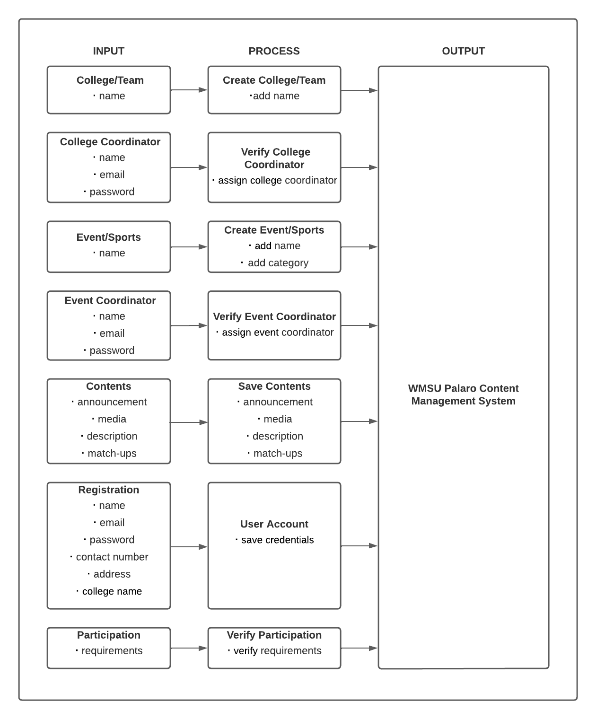

The purpose of the conceptual framework is to show concepts and propose relationships among concepts in the project. It shows the flow and how the system works and process inputs given by the coordinators and students. The flow starts when the admin creates a college module and assign a coordinator that will manage the verification of the student. Then creating of event pages will follow that will contain contents like announcements, media, description and match-ups. Then afterwards students can now register by inputting their credentials as well as the college where they belong and participate to any event available by submitting specific requirement to be later verified by the coordinator.

|  |  |  |  |
| --- | --- | --- | --- |
| **Problem** | **Input** | **Process** | **Output** |
| No availability of information on how to participate in the event | Event/Sports webpage | Contains description and requirements | System provides webpages of each event |
| Manual Registration of Participant in the event | Online Registration | Enter credentials | User has its own dashboard |
| No record of contents | Media links | Provides media links for each event | System displays all the media links provided by the coordinator |
| No record of result of the game | Summary of result | Finalize the result of each event | Displays result of each event |

**3.2 Software Requirements**

The following is the list of software requirements used for development and implementation of the system.

* Laravel Framework- is a free, open-source PHP web framework, and intended for the development of web applications.
* Composer – a tool used to manage dependencies and file autoloading in your PHP project allowing to download packages from multiple repositories.
* XAMPP -Web development tool that is used to develop a web app in localhost
* PHP - is a highly popular and robust server-side open-source programming language for dynamic web applications.

**3.3 Hardware Requirements**

* Computer Device
* Mobile Phone

**CHAPTER 4**

**DESIGN AND METHODOLOGY**

**4.1 Process Model**



Developers can use fast application development to make several iterations and upgrades to the software without having to start a development schedule from scratch each time and developer can also utilize the research and development of the system. The first phase of the system is gathering information and planning the flow of Content Management System and how to implement the main feature of tallying. The second phase of the system is prototyping the system then afterwards researchers can start designing the system. After prototyping, the researcher can start to develop the system for testing phase. Any additional feature that will be added or recommended during the testing phase will be planned by the researcher before adding the feature on the prototype. New features added on the prototype will be reviewed and tested for any error before the system will finally deployed online

**4.2 Requirement Analysis:**

The group intended to record all relevant activities on the Palaro event and the researchers determined what to include in the system after collecting data on the lecture. The researchers also want to carry out a pre-survey where the target user's responses or inquiries during the event will be collected before beginning the construction of the app. This pre-survey is being conducted to assess the best way to create a system that will enable students to take part in the activity. The researcher then began work on constructing the system after obtaining the data from the post-analysis and pre-survey.

**4.2.1 Context Diagram**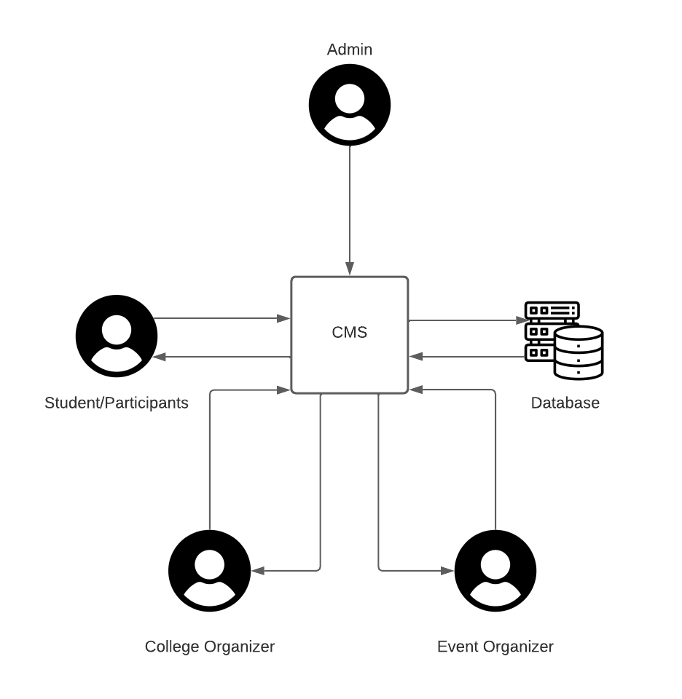

**4.2.2 Data Flow Diagram**

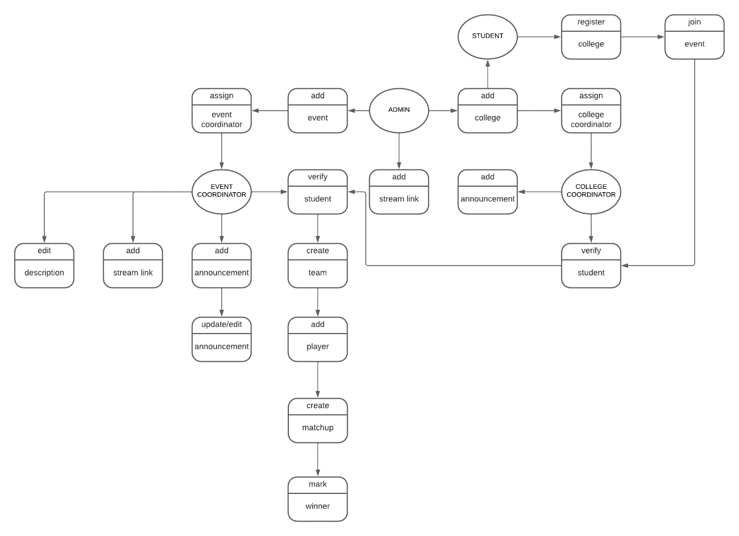

Top level Diagram

The system can add, remove, edit, update and view. In admin can add college and assign a college coordinator for each college, add event and assign an event coordinator. College coordinator will verify student’s participation in the event. Event coordinator will verify the student if he/she is qualified to participate in the event. Qualified participants will be added to respected team for the matchup.

**4.2.3 User Interface Design**

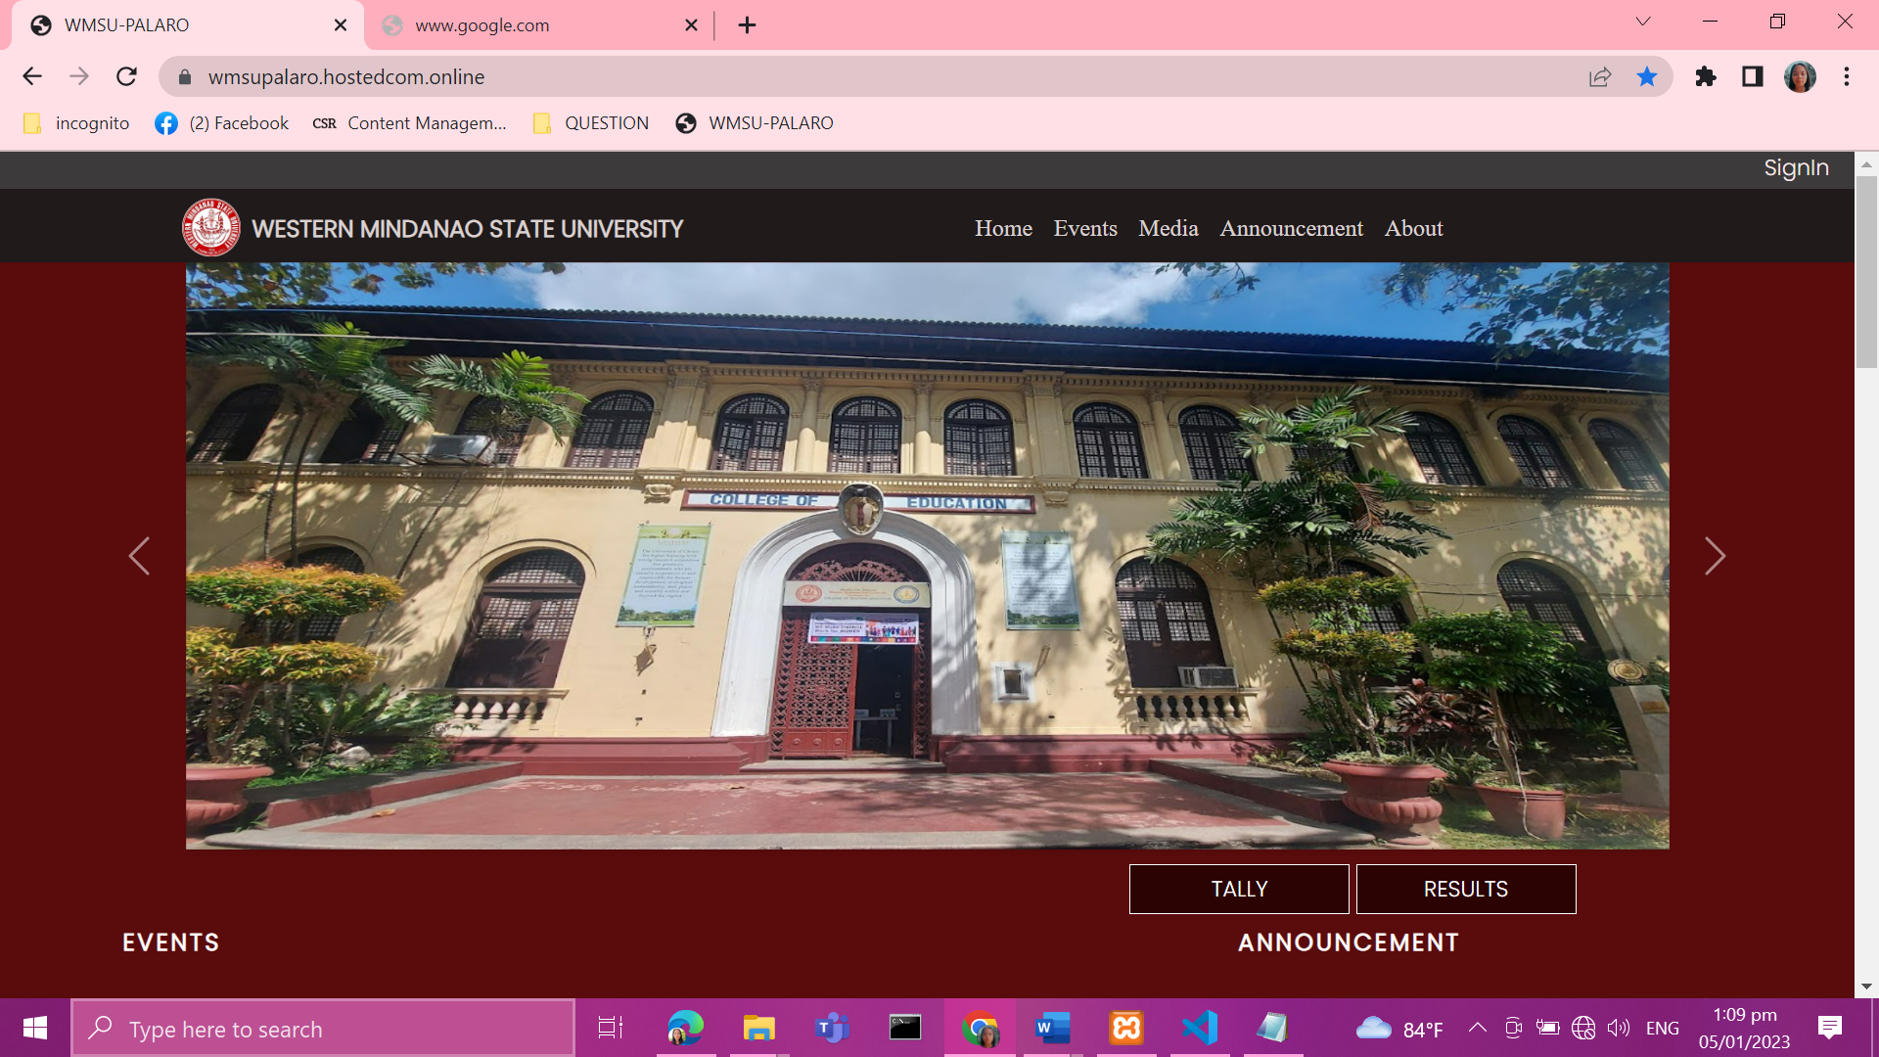

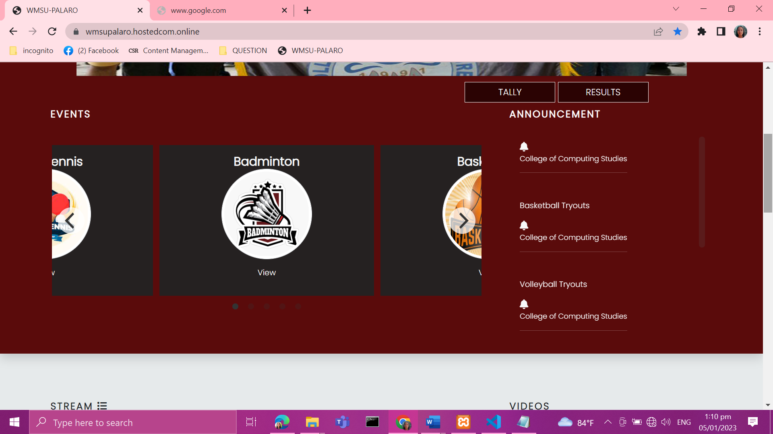

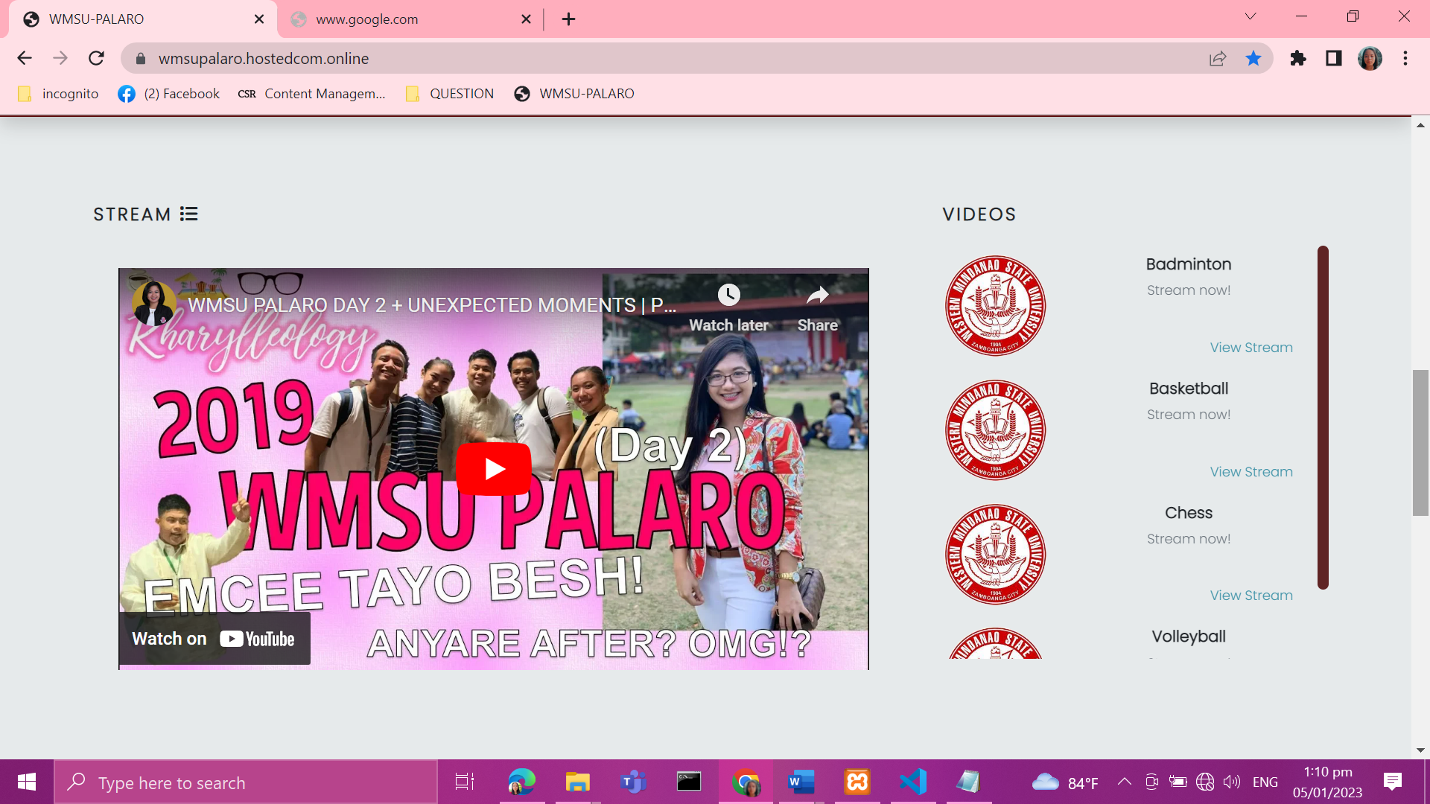

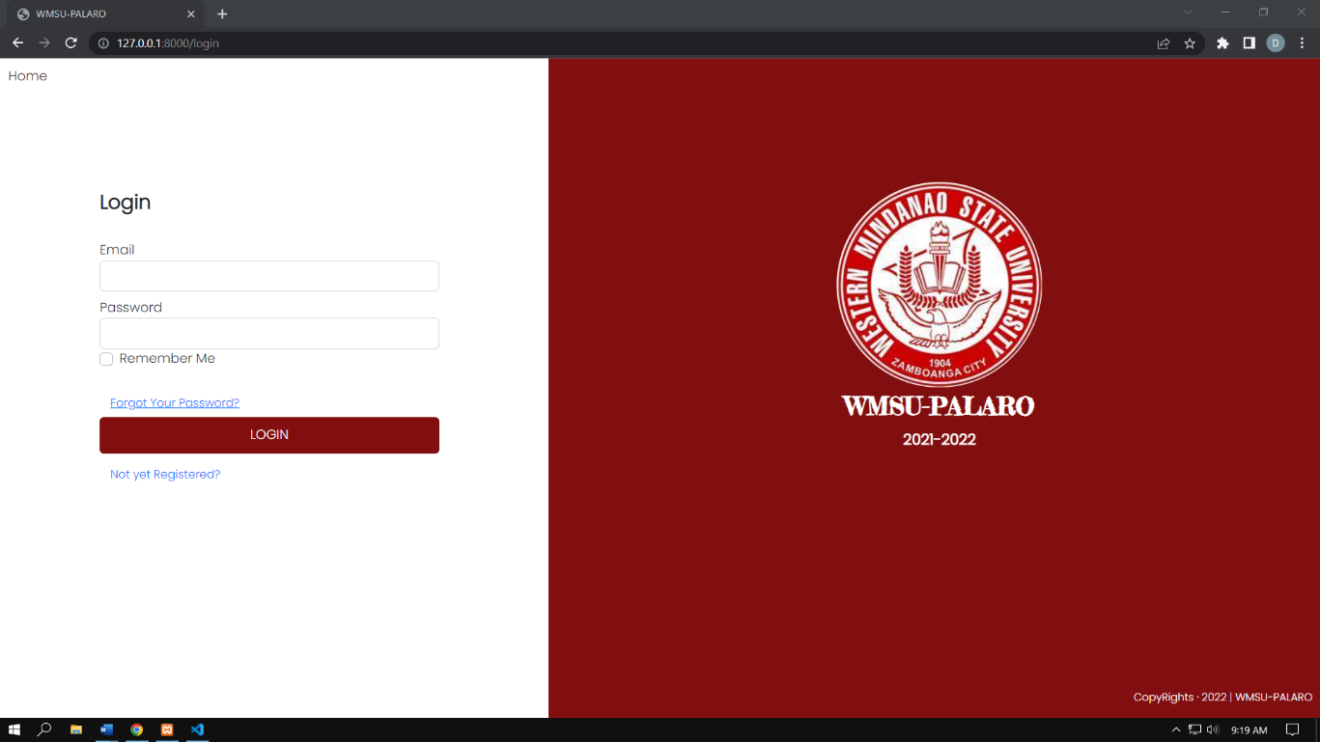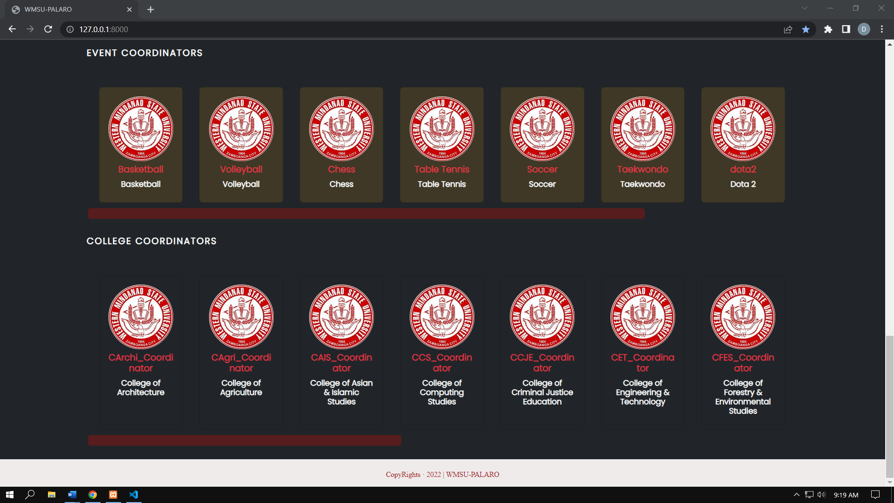

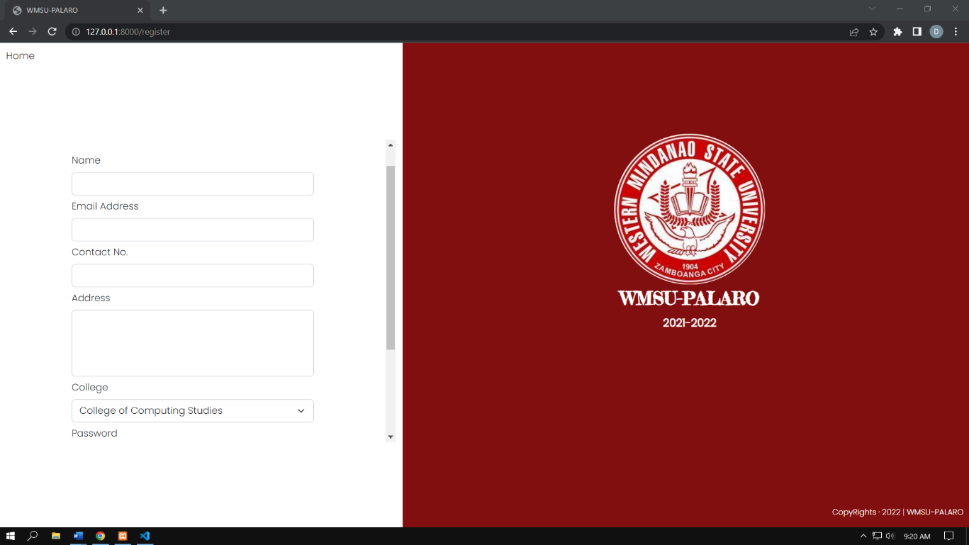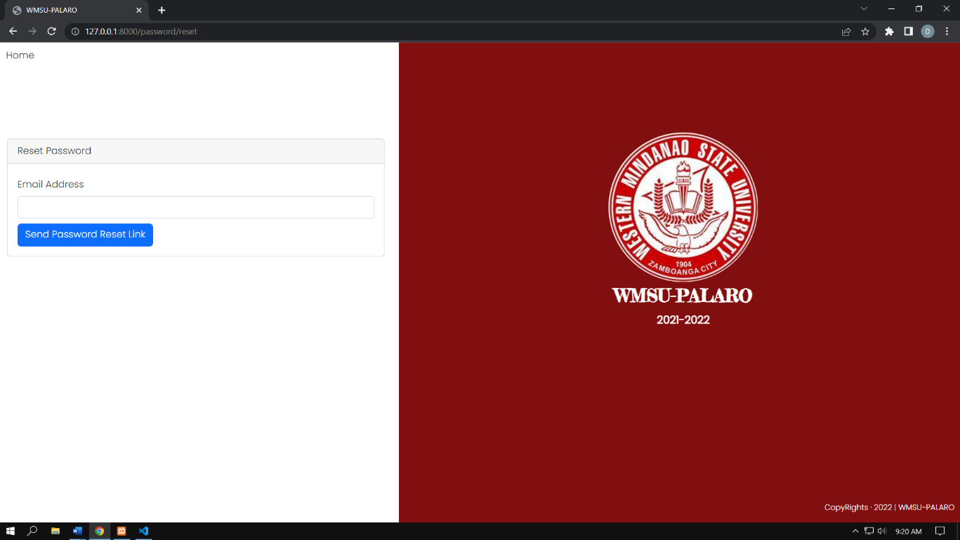

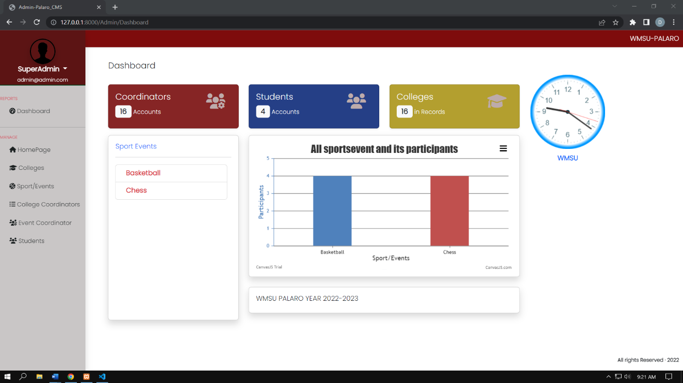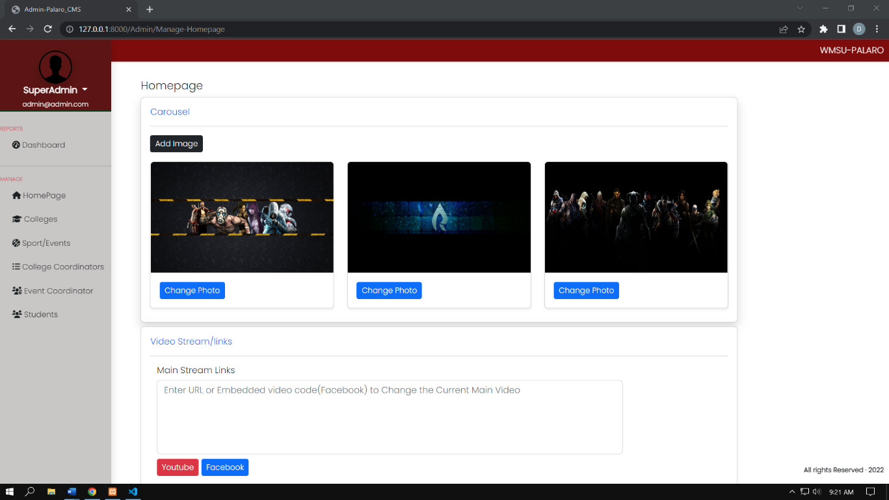

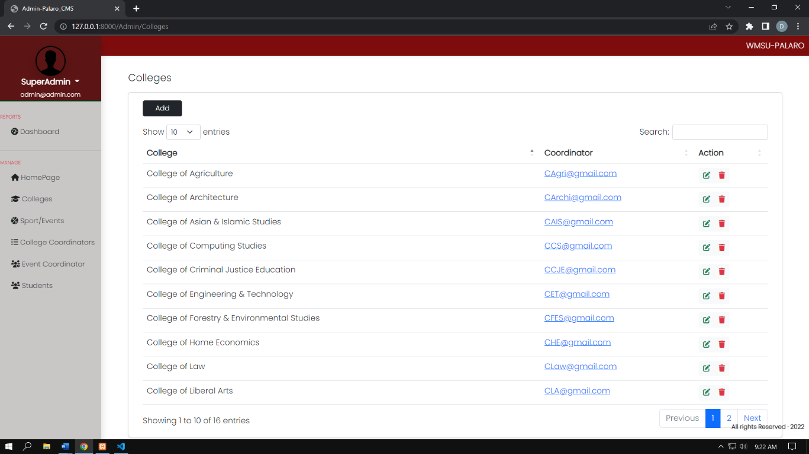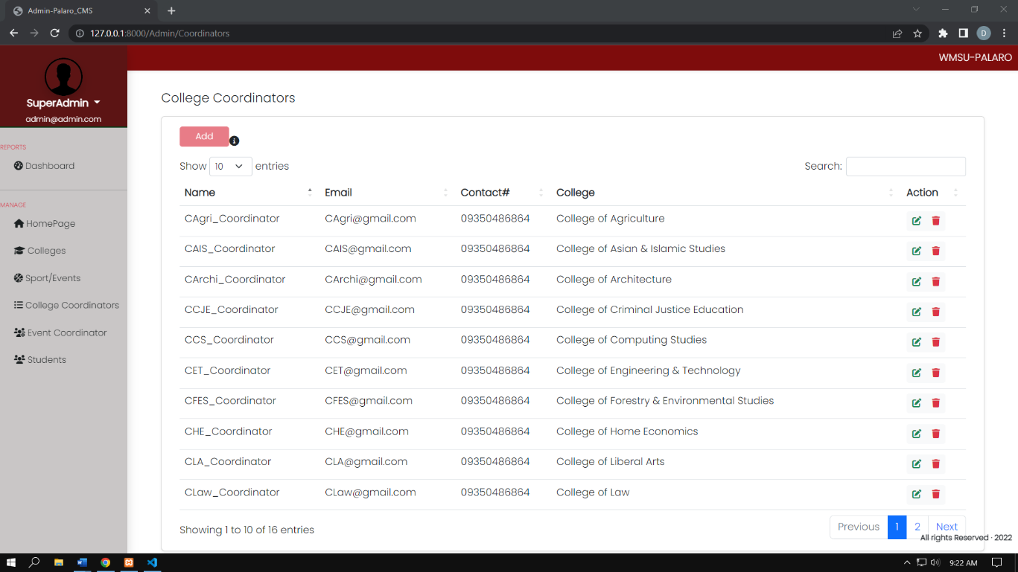

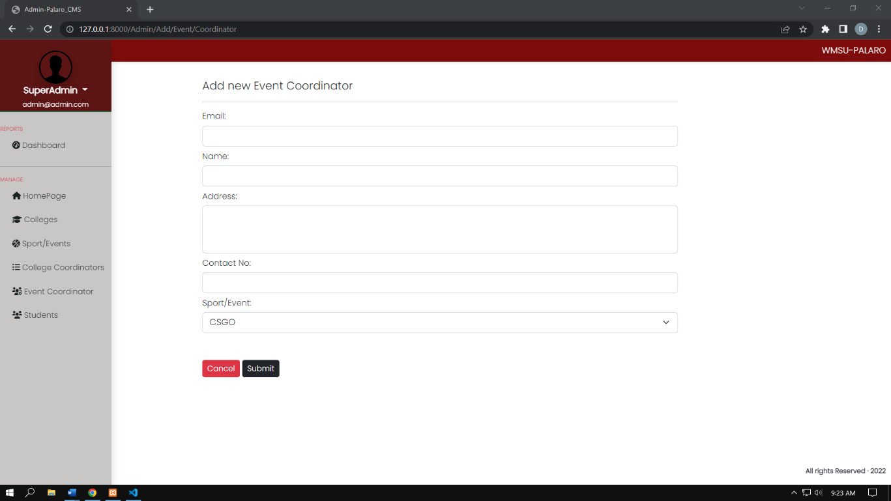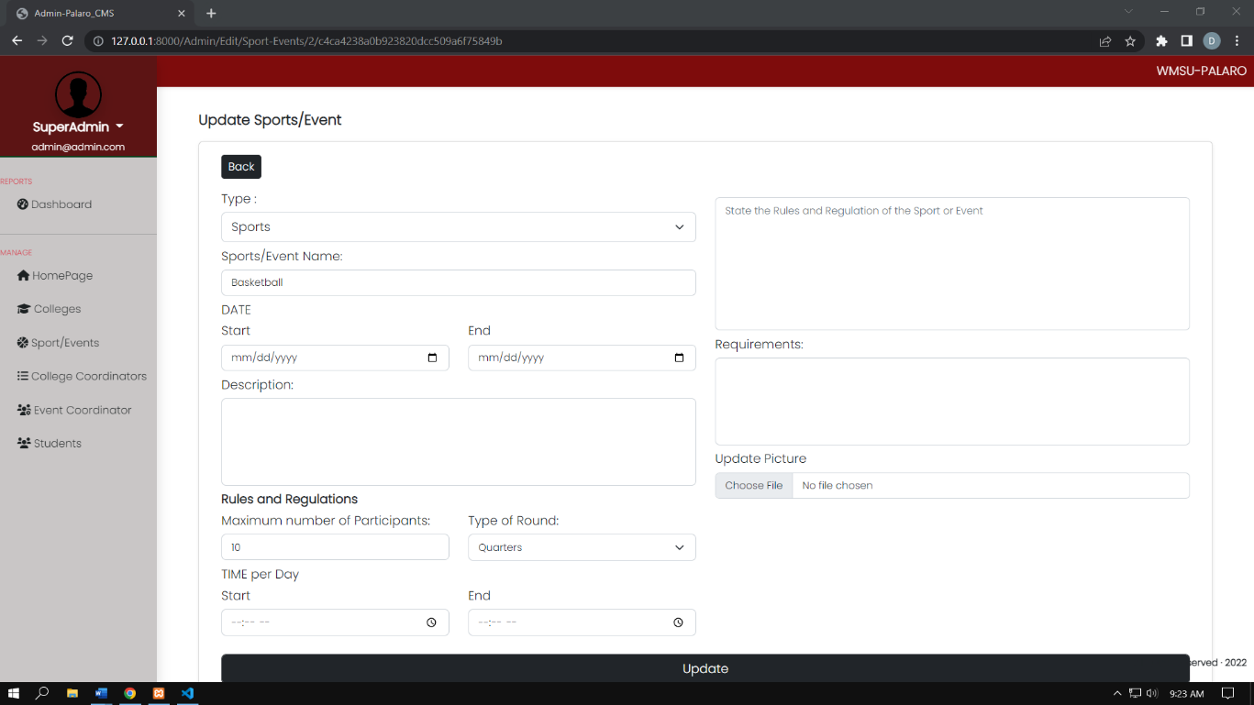

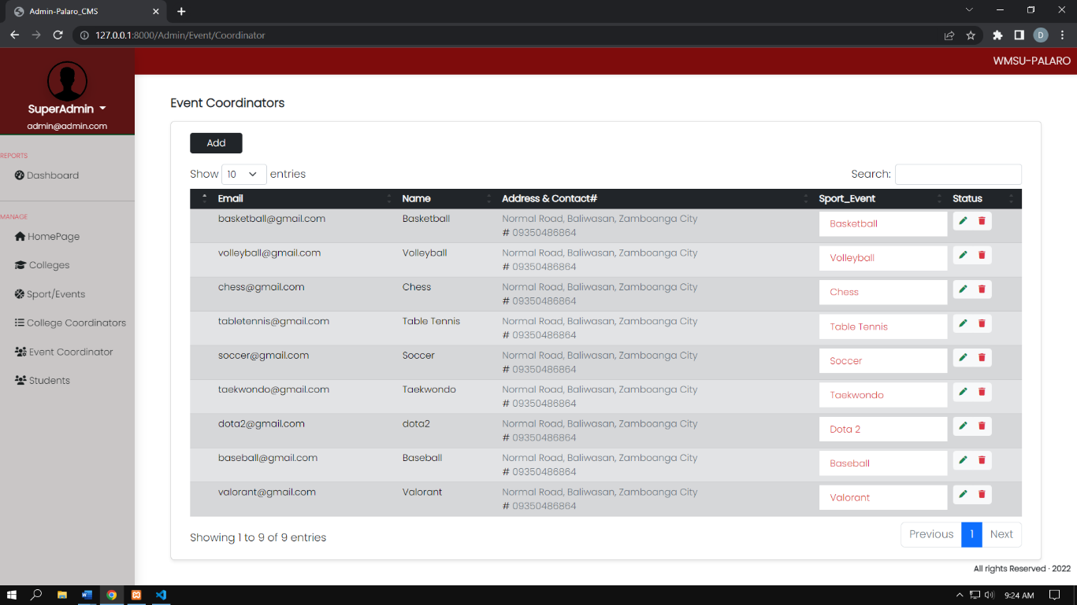

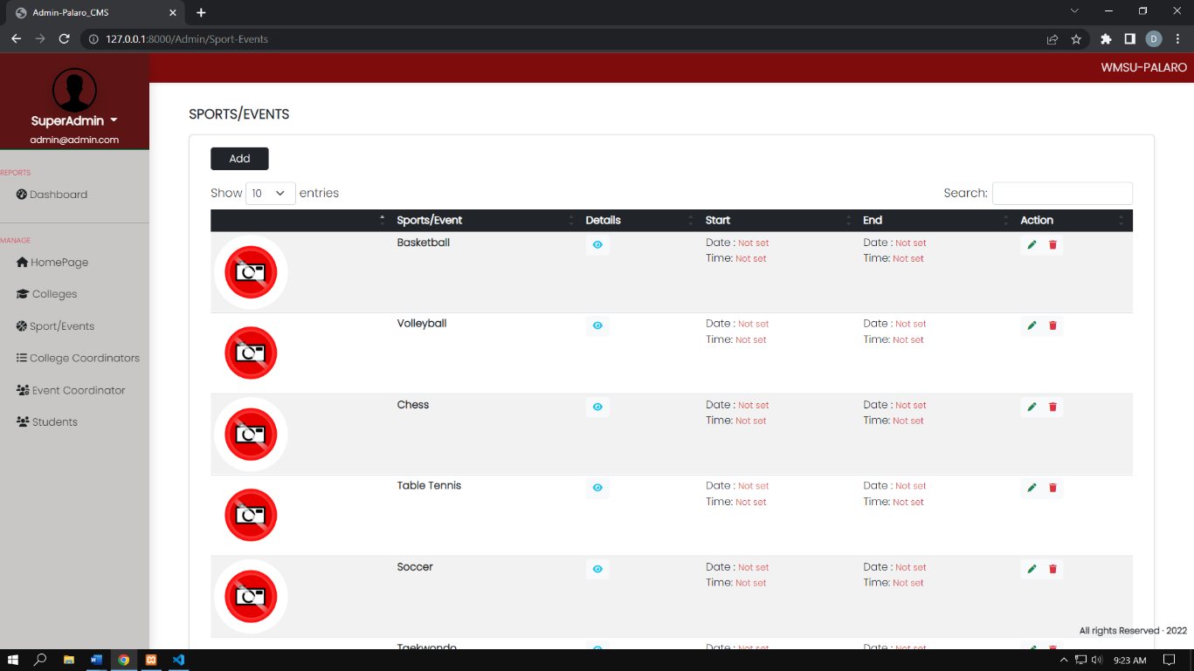

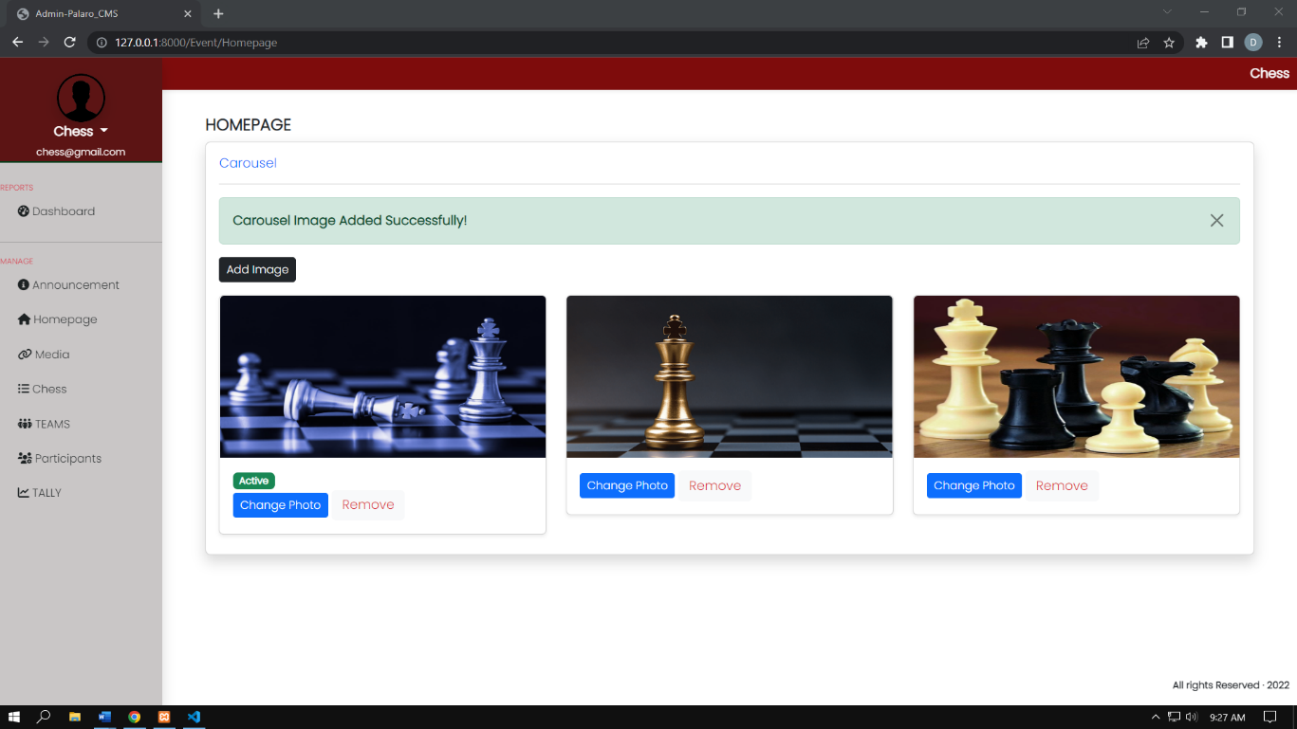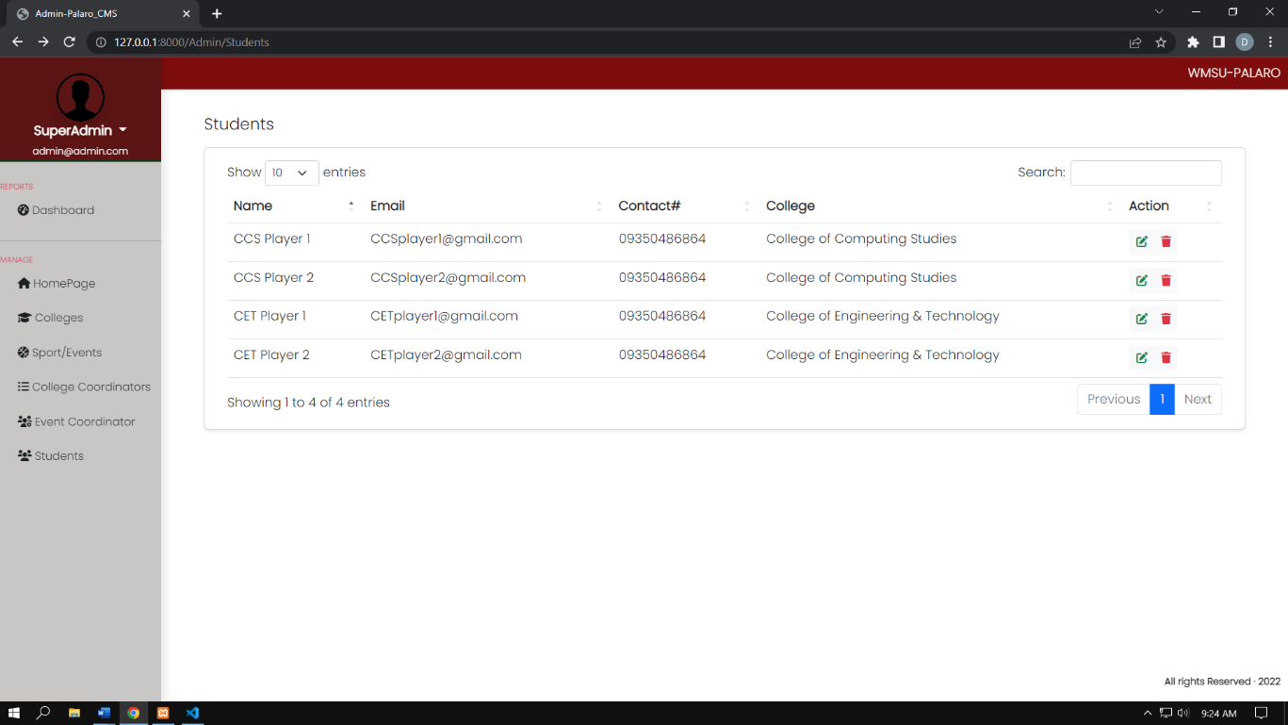

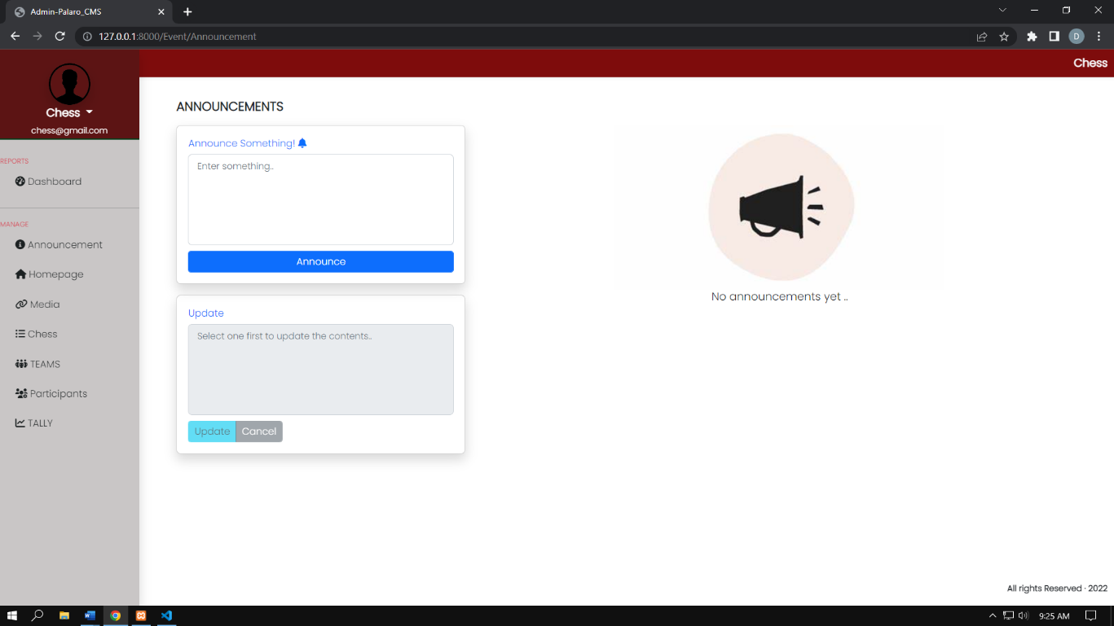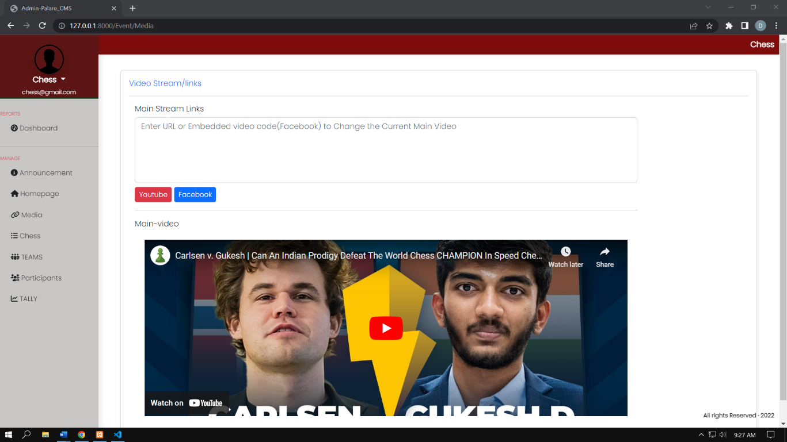

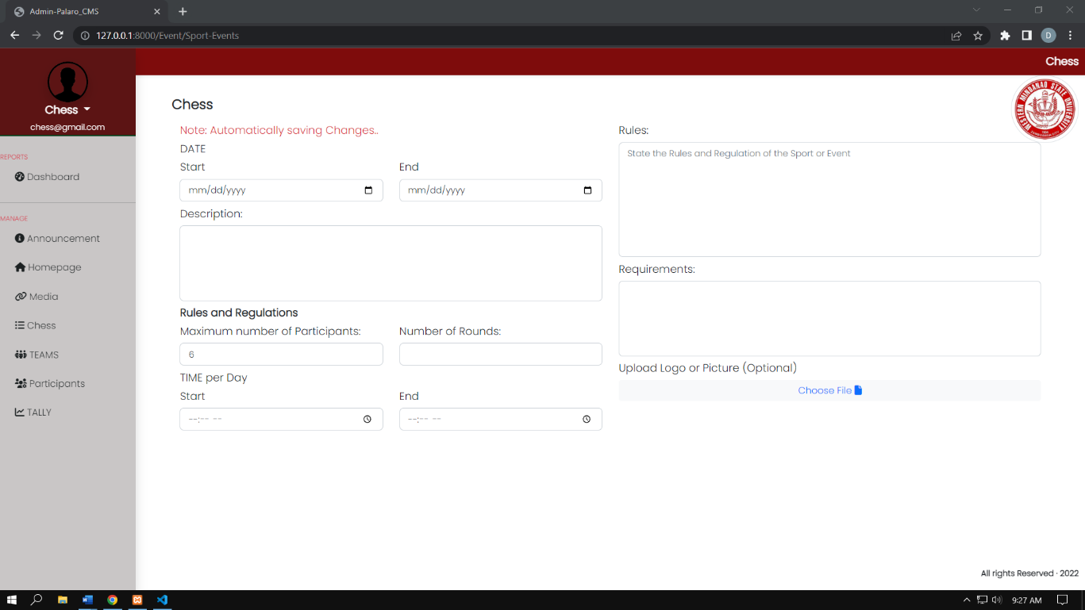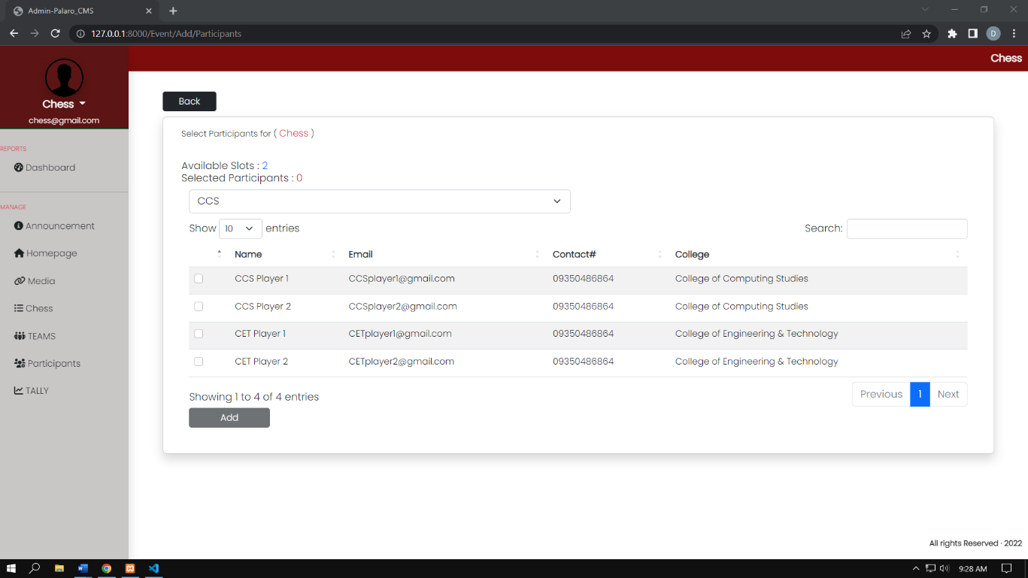

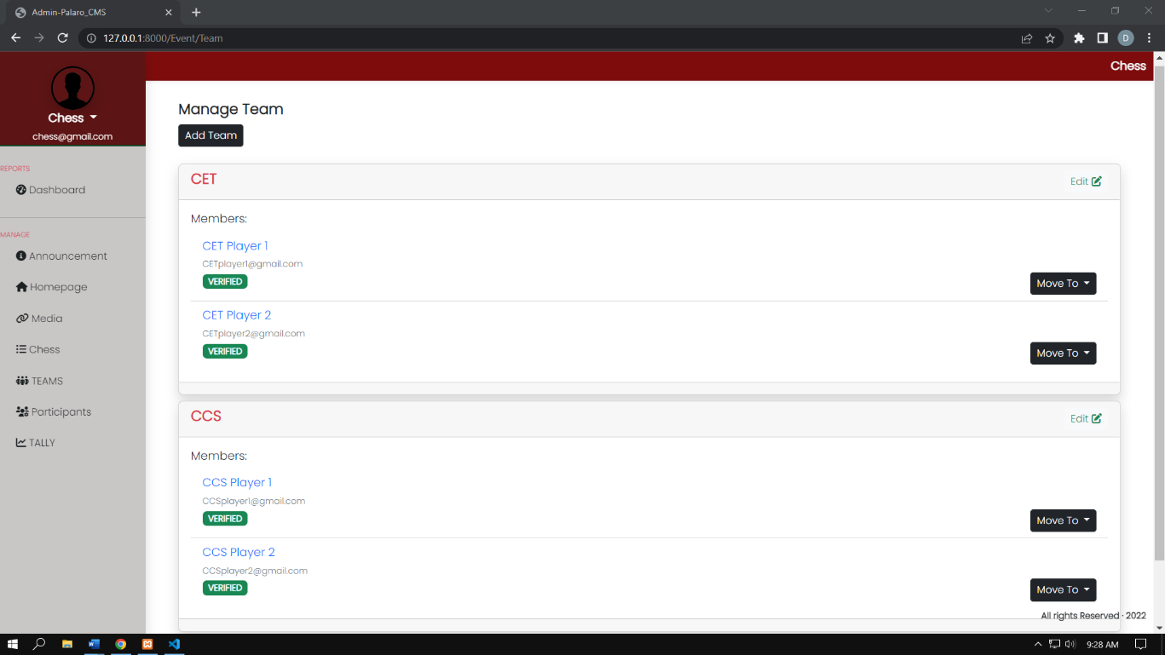

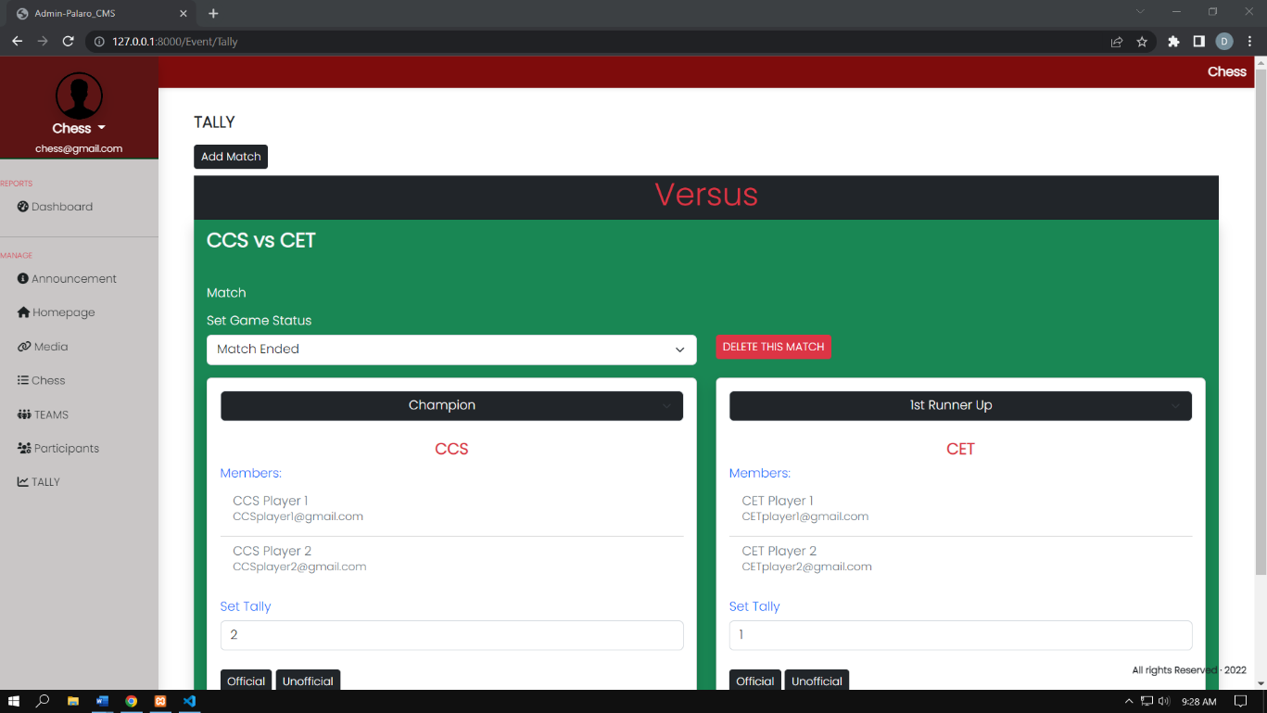

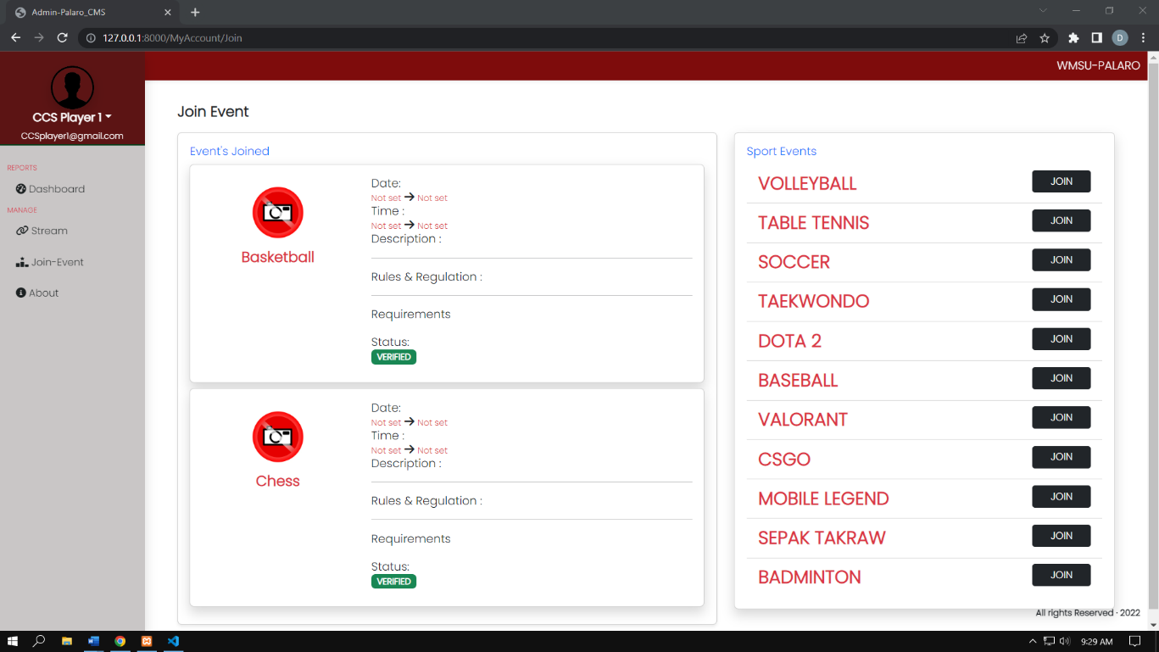

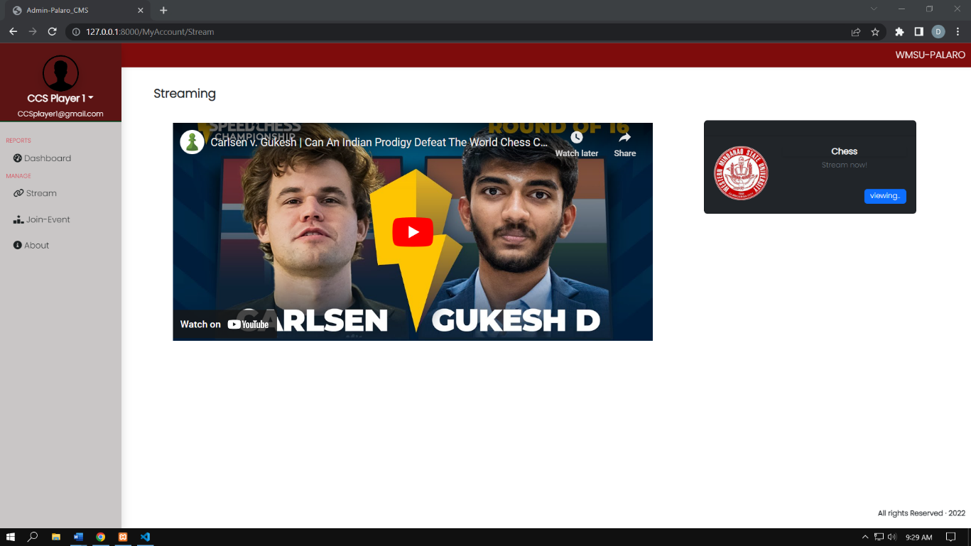

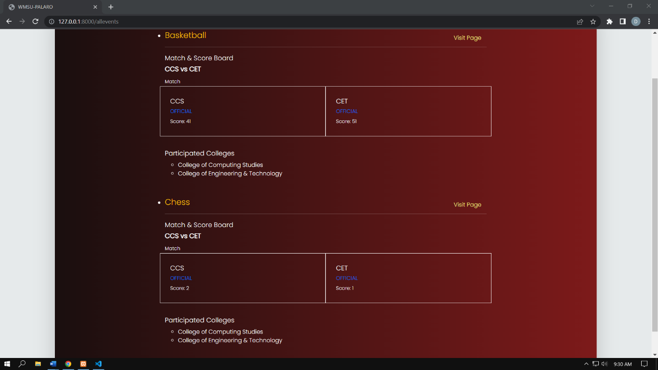

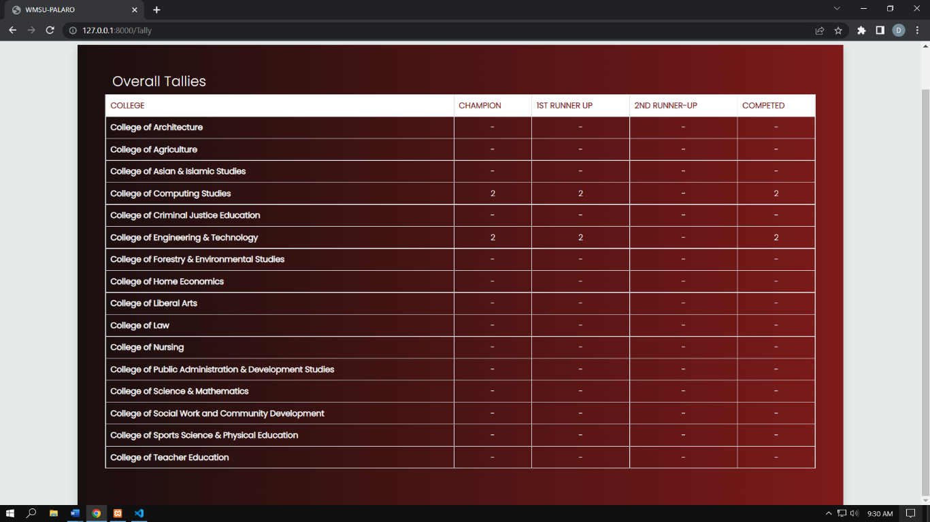

**4.2.4 Use Case Diagram**

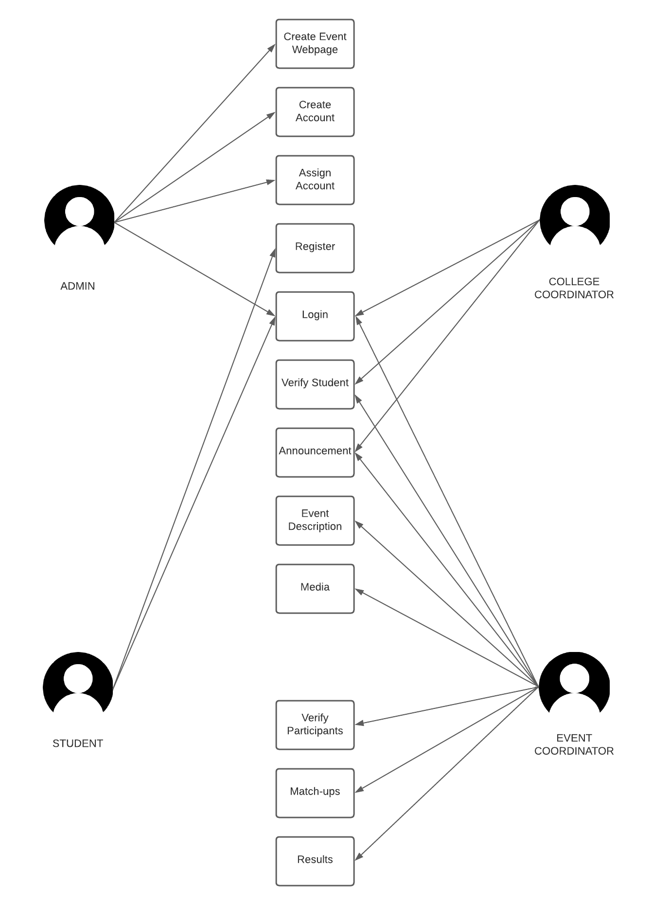

|  |  |  |  |
| --- | --- | --- | --- |
| Use Case ID: | **1** | | |
| Use Case Name: | **College** | | |
| Created By: | Admin | Last Updated By: |  |
| Date Created: |  | Date Last Updated: |  |
| Actor: | admin | | |
| Description: | Admin create a college module for the student to register | | |
| Preconditions: | Admin can Create delete edit and update account | | |
| Postconditions: | Admin can modify and account | | |
| Priority: | high | | |
| Normal Course of Events: | 1. Admin create a college module 2. System will automatically recognize the new college 3. Admin can delete the college 4. The system will delete the college 5. Admin can modify the college 6. The system allows the admin to modify the college | | |
| Alternative Courses: | 1.If the created college has already existed the system will notify the admin  2. the system recognizes the new created college | | |
| Exceptions: |  | | |
| Use Case ID: | **2** | | |
| Use Case Name: | **College Coordinator Account** | | |
| Created By: | admin | Last Updated By: |  |
| Date Created: |  | Date Last Updated: |  |
| Actor: | admin | | |
| Description: | Admin can create delete edit and update college | | |
| Preconditions: | The system will allow the admin to modify the college coordinator account | | |
| Postconditions: |  | | |
| Priority: | High | | |
| Normal Course of Events: | 1. the admin creates and assign a college coordinator account 2. the admin can retrieve the account like forgotten password | | |

|  |  |  |  |
| --- | --- | --- | --- |
|  | 1. the admin can delete a college coordinator account 2. the system will delete the college coordinator account 3. the system can edit college coordinator account 4. the system recognizes the edited in the college and automatically updated after refreshing the website | | |
| Alternative Courses: | 1.If the account is already existing the system will notify the admin | | |
| Exceptions: |  | | |
| Use Case ID: | **3** | | |
| Use Case Name: | **Event** | | |
| Created By: | Admin | Last Updated By: |  |
| Date Created: |  | Date Last Updated: |  |
| Actor: | admin | | |
| Description: | Admin create an event webpage for the content | | |
| Preconditions: | Admin can Create delete edit and update event webpage | | |
| Postconditions: | Admin can modify the webpage | | |
| Priority: | high | | |
| Normal Course of Events: | 1. Admin create an event webpage 2. System will automatically recognize the new event 3. Admin can delete the event webpage 4. The system will delete the event webpage 5. The system allows the admin to modify the college | | |
| Alternative Courses: | 1.If the created event has already existed the system will notify the admin  2. the system recognizes the new created college | | |
| Exceptions: |  | | |
| Use Case ID: | **4** | | |
| Use Case Name: | **Event Coordinator Account** | | |
| Created By: | admin | Last Updated By: |  |
| Date Created: |  | Date Last Updated: |  |
| Actor: | admin | | |
| Description: | Admin can create delete edit and update event coordinator account | | |
| Preconditions: | The system will allow the admin to modify the event coordinator account | | |
| Postconditions: |  | | |
| Priority: | High | | |
| Normal Course of Events: | 1. the admin creates and assign a event coordinator account 2. the admin can retrieve the account like forgotten password | | |
| Use Case ID: | **5** | | |
| Use Case Name: | **Announcement** | | |
| Created By: | Event coordinator & College Coordinator | Last Updated By: |  |
| Date Created: |  | Date Last Updated: |  |
| Actor: | Event coordinator & College Coordinator | | |
| Description: | Both coordinators can create delete edit and update announcement | | |
| Preconditions: | The system will allow the coordinators to modify the announcement | | |
| Postconditions: |  | | |
| Priority: | High | | |
| Normal Course of Events: | 1. the coordinators can create, delete, edit and update an announcement | | |
| Alternative Courses: |  | | |
| Exceptions: |  | | |
| Use Case Name: | **Participant** | | |
| Created By: | Student | Last Updated By: |  |
| Date Created: |  | Date Last Updated: |  |
| Actor: | Event coordinator & College Coordinator | | |
| Description: | Both coordinators can create delete edit and update participants | | |
| Preconditions: | The system will allow the coordinators to modify the participants | | |
| Postconditions: |  | | |
| Priority: | high | | |
| Normal Course of Events: | 1. Students can join event as participant 2. Students can submit documents 3. Participants will be verified first by their College Coordinator 4. College Coordinator can add, delete students 5. Participants will be verified by the Event Coordinator 6. Event Coordinator can add, delete participants | | |
| Alternative Courses: |  | | |
| Exceptions: |  | | |
| Use Case ID: | **6** | | |
| Use Case Name: | **Announcement** | | |
| Created By: | Event coordinator & College Coordinator | Last Updated By: |  |
| Date Created: |  | Date Last Updated: |  |
| Actor: | Event coordinator & College Coordinator | | |
| Description: | Both coordinators can create delete edit and update announcement | | |
| Preconditions: | The system will allow the coordinators to modify the announcement | | |
| Postconditions: |  | | |
| Priority: | High | | |
| Normal Course of Events: | 1. the coordinators can create, delete, edit and update an announcement | | |
| Alternative Courses: |  | | |
| Exceptions: |  | | |
| Use Case ID: | **7** | | |
| Use Case Name: | **Media** | | |
| Created By: | Event coordinator & Admin | Last Updated By: |  |
| Date Created: |  | Date Last Updated: |  |
| Actor: | Event coordinator & Admin | | |
| Description: | Admin and Event coordinators can add or remove stream link from Facebook or YouTube | | |
| Preconditions: | The system will allow the admin & event coordinators to include stream link | | |
| Postconditions: |  | | |
| Priority: | High | | |
| Normal Course of Events: | 1. the admin & event coordinators can provide a link of the event from Facebook & YouTube | | |
| Alternative Courses: |  | | |
| Exceptions: |  | | |
| Use Case ID: | **8** | | |
| Use Case Name: | **Matchup** | | |
| Created By: | Event coordinator | Last Updated By: |  |
| Date Created: |  | Date Last Updated: |  |
| Actor: | Event coordinator | | |
| Description: | Event coordinators can create delete edit and update team matchup | | |
| Preconditions: | The system will allow the coordinators to modify the match up  The team must contain at least 1 player for the matchup | | |
| Postconditions: |  | | |
| Priority: | High | | |
| Normal Course of Events: | 1. the coordinators can create, delete, edit and update an announcement | | |
| Alternative Courses: |  | | |
| Exceptions: |  | | |
| Use Case ID: | **9** | | |
| Use Case Name: | **Register** | | |
| Created By: | Student | Last Updated By: |  |
| Date Created: |  | Date Last Updated: |  |
| Actor: | Student | | |
| Description: | Students can register online | | |
| Preconditions: | The system must contain a college for the student to register | | |
| Postconditions: |  | | |
| Priority: | High | | |
| Normal Course of Events: | 1. students can enter their credentials to register 2. students can join to any available event | | |
| Alternative Courses: |  | | |
| Exceptions: |  | | |
|  |  | | |

* 1. **Hardware Interface**

|  |  |  |
| --- | --- | --- |
| **Hardware Interface** | **Component needed** | **Purpose** |
| Computer |  | To be able to log in in the system |
| cellphone |  | To be able to log in in the system |

* 1. **Software Interface**

|  |  |  |
| --- | --- | --- |
| **Software Interface** | **Component needed** | **Purpose** |
| Laravel |  | We’re using Laravel for the Front end |
| HTML |  | We use HTML for the design |
| PHP |  | We are using PHP for our backend |

* 1. **Communication Interface**

|  |  |  |
| --- | --- | --- |
| **Communication Interface** | **Component needed** | **Purpose** |
| Internet |  | To be Able to connect to the website |
| Server |  | To be able to connect to user and  content creator |

* 1. **System Requirement**

|  |  |
| --- | --- |
| **Admin** | |
| Creating a page for the sports events | Allow the admin to create/remove a webpage of the event. |
| Assigning an account for the organizer of the event | Allow the admin to assign/remove an account for each event that will manage the content. |
| Create a module for the colleges | Allow the admin to create/remove a module of the college |
| Assigning an account for each college coordinator | Allow the admin to assign an account to each college coordinator to verify the registration of participants |

|  |  |
| --- | --- |
| **Event Coordinator** | |
| Verify participants | Allow event coordinator to verify the participants based on the submitted documents |
| Uploading content for the page | Allow the coordinator to create, read, update, delete content for the webpage. this includes:   * Announcements * Description * Rules & Criteria * Documents * Media * Participants |
| Display the winners of each event | Allows the coordinator to mark the winners of the game. |

|  |  |
| --- | --- |
| **College Coordinator** | |
| Verify students | Allow college coordinator to verify the students based on the submitted documents |
| Upload announcement | allow college coordinator to post announcement |

|  |  |
| --- | --- |
| **Student** | |
| Register online | Allow students to register online |
| Join event | Allow students to join an event by submitting required document |

**4.4 Usability Requirements**

* + Admin can create and delete webpage for the event
  + Event Coordinator can upload, update and delete content of the page
  + College coordinator can filter the registered
  + User can view contents posted on the webpage
  + Student can register online.

**4.5 Operational Requirements**

* If there’s a need to change in the system features and requirements existing information should remain unchanged.
* The system should handle multiple content display on the webpage
* The system should display the per college win count.

**CHAPTER 5**

**DEVELOPMENT AND TESTING**

**5.1 Development**

The development phase includes front end & back end of the system. We used HTML, CSS, Bootstrap5 & Jquery as our frontend and for backend, we use the Laravel framework for its model-view-controller approach. The team should keep communicating for the system update and adjustment. Every change in the system, each member should be updated each member should test the function to ensure the system is working properly.

**5.2 Testing**

Testing The researcher conducted various test on the system to ensure the intended function is working properly and to test the accuracy of tallying functions of the system.

**5.2.1: Alpha Testing**

The purpose of the test is to test the output of the system if the system produces the expected result and test the functions of the system for any error.

**5.2.2: Beta Testing**

The purpose of the test is to evaluate the performance of the system in a real time environment. Researchers include 15 random students as respondents to register online and provide insights, suggestion, and feedback based on their experience.

**5.3: Implementation Plan**

The researchers proposed the title to the teachers of CCS department. The approved title was given a time frame of 4 months to finish the system including the design and the implementation of the function. The researcher prepares a detailed plan for the implementation including the additional feature suggested by our title adviser. After each of the functions and module undergo a unit testing, the researcher asks random respondents to explore and give insights to the system. The respondent was given a questionnaire to rate their experience in using the system. The questionnaire used by the researcher is PSSUQ (Post Study System Usability Questionnaire) created by Jim Lewis which has 3 sections system usability, information quality and interface.

**CHAPTER 6**

**RESULTS AND DISCUSSIONS**

**6.1 Introduction**

**6.1.1 Test Case Results**

|  |  |  |  |
| --- | --- | --- | --- |
| **Test Case #: 1**  **Test Case Name:** Providing Media Link for Homepage  **Test Case Description:** In this module the system enables the admin to input link form YouTube & Facebook. | | | |
| **Test Case** | | | **Remarks** |
| **Test Case** | **Expected Result** | **Actual Result** |
| Integration of Media Link | In this module the system can be able to play the media link from YouTube & Facebook. | The media link is accessible | PASS |
| **Completed Date:** December 18, 2022 | | | |

|  |  |  |  |
| --- | --- | --- | --- |
| **Test Case #: 2**  **Test Case Name:** Adding College & Event Module  **Test Case Description:** In this module the system enables the admin to add college name and event name. | | | |
| **Test Case** | | | **Remarks** |
| **Test Case** | **Expected Result** | **Actual Result** |
| Adding College & Event Module | In this module the system can display the names of colleges and events. | The name of colleges & events was accessible at the homepage | PASS |
| **Completed Date:** December 18, 2022 | | | |

|  |  |  |  |
| --- | --- | --- | --- |
| **Test Case #: 3**  **Test Case Name:** College & Event Coordinator Account with Login Module  **Test Case Description:** In this module the system enables the content manager to login using the email and password provided by the Admin. | | | |
| **Test Case** | | | **Remarks** |
| **Test Case** | **Expected Result** | **Actual Result** |
| Integration of College & Event Coordinator Account with Login Module | In this module it enables the content manager to login with the email and password given by the admin. | The email and password that was created by the admin was accessible. | PASS |
| **Completed Date:** December 18, 2022 | | | |

|  |  |  |  |
| --- | --- | --- | --- |
| **Test Case #: 4**  **Test Case Name:** Student Registration  **Test Case Description:** In this module the system enables the student to register online by inputting their credentials. | | | |
| **Test Case** | | | **Remarks** |
| **Test Case** | **Expected Result** | **Actual Result** |
| Student Registration | In this module the system enables the student to register online by inputting their credentials | The student can register online if at least 1 college is created by the admin | PASS |
| **Completed Date:** December 18, 2022 | | | |

|  |  |  |  |
| --- | --- | --- | --- |
| **Test Case #: 5**  **Test Case Name:** Student Joining an Event  **Test Case Description:** In this module the system enables the student to join any available event by submitting required document | | | |
| **Test Case** | | | **Remarks** |
| **Test Case** | **Expected Result** | **Actual Result** |
| Student Joining an Event | In this module the system enables the student to join any available event by submitting required document | The student can join all available event | PASS |
| **Completed Date:** December 18, 2022 | | | |

|  |  |  |  |
| --- | --- | --- | --- |
| **Test Case #: 6**  **Test Case Name:** College Coordinator verifying student  **Test Case Description:** In this module the system enables the College coordinator to verify students to participate in the event | | | |
| **Test Case** | | | **Remarks** |
| **Test Case** | **Expected Result** | **Actual Result** |
| College Coordinator verifying student | In this module the College coordinator can check the submitted requirement to verify students to participate in the event | The college coordinator can verify multiple participated events from a single student | PASS |
| **Completed Date:** December 18, 2022 | | | |

|  |  |  |  |
| --- | --- | --- | --- |
| **Test Case #: 7**  **Test Case Name:** Event Coordinator verifying participants  **Test Case Description:** In this module the system enables the Event coordinator to verify participants in the event | | | |
| **Test Case** | | | **Remarks** |
| **Test Case** | **Expected Result** | **Actual Result** |
| Event Coordinator verifying participants | In this module the event coordinator can check the submitted requirement to verify participants in the event | The event coordinators can verify only one event from a single verified student | PASS |
| **Completed Date:** December 18, 2022 | | | |

|  |  |  |  |
| --- | --- | --- | --- |
| **Test Case #: 8**  **Test Case Name:**  College & Event Coordinators posting announcement  **Test Case Description:** In this module the system enables the College & Event coordinator to post announcement. | | | |
| **Test Case** | | | **Remarks** |
| **Test Case** | **Expected Result** | **Actual Result** |
| Posting announcement of College & Event Coordinators | In this module the college & event coordinator can post announcement which will be displayed at the homepage | The college & event coordinators posted announcement was accessible | PASS |
| **Completed Date:** December 18, 2022 | | | |

|  |  |  |  |
| --- | --- | --- | --- |
| **Test Case #: 9**  **Test Case Name:**  Event Coordinators adding players to the college team  **Test Case Description:** In this module the system enables the Event coordinator create & assign players to the college team | | | |
| **Test Case** | | | **Remarks** |
| **Test Case** | **Expected Result** | **Actual Result** |
| Event Coordinators adding players to the college team | In this module the Event coordinator can create & assign players to the college team | The module was able to create and assign players to the team. The event coordinator can move players to different team | PASS |
| **Completed Date:** December 18, 2022 | | | |

|  |  |  |  |
| --- | --- | --- | --- |
| **Test Case #: 10**  **Test Case Name:**  Event Coordinators creating matchups  **Test Case Description:** In this module the system enables the Event coordinator create matchups of the college teams | | | |
| **Test Case** | | | **Remarks** |
| **Test Case** | **Expected Result** | **Actual Result** |
| Event Coordinators creating matchups | In this module the system enables the Event coordinator create matchups of the college teams | The module was able to create multiple matchups. The event coordinator can mark the matchups as pending, on-going and ended | PASS |
| **Completed Date:** December 18, 2022 | | | |

|  |  |  |  |
| --- | --- | --- | --- |
| **Test Case #: 11**  **Test Case Name:**  Event Coordinators declare winner for the tally  **Test Case Description:** In this module the system enables the Event coordinator to declare the winning team for tallying result. | | | |
| **Test Case** | | | **Remarks** |
| **Test Case** | **Expected Result** | **Actual Result** |
| Event Coordinators declare winner for the tally | In this module the system enables the Event coordinator to declare the winning team for tallying result. | The module was able to tally the result as per team & per participants. | PASS |
| **Completed Date:** December 18, 2022 | | | |

**6.2 Test Case Report**

|  |  |  |  |  |
| --- | --- | --- | --- | --- |
| **ID** | **Action** | **Expected Result** | **Actual Result** | **Remark** |
| **A** | **Coordinator’s Login Module** | | | |
| A1 | * Correct Email Correct Password | It will direct you to the account dashboard | Same as expected | PASS |
| A2 | * Correct Email Wrong Password | a message will prompt “credentials do not match our record” | Same as expected | PASS |
| A3 | * No Email No Password | a message will prompt “credentials do not match our record” | Same as expected | PASS |
| A4 | * Correct Email * No Password | a message will prompt “credentials do not match our record” | Same as expected | PASS |
| A5 | * No Email * Correct Password | a message will prompt “credentials do not match our record” | Same as expected | PASS |
| **B** | **Super-admin Account Module** | | | |
| B1 | * Correct College Name | a message will prompt “College added successfully!” |  | PASS |
| B2 | * No college names | a message will prompt “please fill out this field” |  | PASS |
| B3 | * Duplicate college names | a message will prompt “College Already Exist” |  | PASS |
| B4 | * Correct email * Correct College coordinator email * Correct address * Correct contact number | a message will prompt “Account added successfully!” | Same as expected | PASS |
| B5 | * Correct email * No College coordinator email * No address * No contact number | a message will prompt “please fill out this field” | Same as expected | PASS |
| B6 | * No email * Correct College coordinator email * No address * No contact number | a message will prompt “please fill out this field” | Same as expected | PASS |
| B7 | * No email * No College coordinator email * Correct address * No contact number | a message will prompt “please fill out this field” | Same as expected | PASS |
| B8 | * No email * No College coordinator email * No address * Correct contact number | a message will prompt “please fill out this field” | Same as expected | PASS |
| B9 | * Duplicate email * Correct College coordinator email * Correct address * Correct contact number | a message will prompt “The email has already taken” | Same as expected | PASS |
| B10 | * Correct Event Name | a message will prompt “Sport/Event added successfully” | Same as expected | PASS |
| B11 | * No Event Name | a message will prompt “Required” | Same as expected | PASS |
| B12 | * Correct email * Correct Event coordinator name * Correct address * Correct contact number | a message will prompt “Account added successfully!” | Same as expected | PASS |
| B13 | * Correct email * No Event coordinator name * No address * No contact number | a message will prompt “please fill out this field” | Same as expected | PASS |
| B14 | * No email * Correct Event coordinator name * No address * No contact number | a message will prompt “please fill out this field” | Same as expected | PASS |
| B15 | * No email * No Event coordinator name * Correct address * No contact number | a message will prompt “please fill out this field” | Same as expected | PASS |
| B16 | * No email * No Event coordinator name * No address * Correct contact number | a message will prompt “please fill out this field” | Same as expected | PASS |
| B17 | * Duplicate email * Correct Event coordinator name * Correct address * Correct contact number | a message will prompt “The email has already taken” | Same as expected | PASS |
| **C** | **Student Online Registration Module** | | | |
| C1 | * Correct name * Correct email * Correct contact numbers * Correct address * Correct password * Correct password verification | It will direct you to the account dashboard | Same as expected | PASS |
| C2 | * No name * Correct email * Correct contact numbers * Correct address * Correct password * Correct password verification | a message will prompt “Please fill out this field” | Same as expected | PASS |
| C3 | * Correct name * No email * Correct contact numbers * Correct address * Correct password * Correct password verification | a message will prompt “Please fill out this field” | Same as expected | PASS |
| C4 | * Correct name * Correct email * No contact numbers * Correct address * Correct password * Correct password verification | a message will prompt “Please fill out this field” | Same as expected | PASS |
| C5 | * Correct name * Correct email * Correct contact numbers * Correct address * No password * Correct password verification | a message will prompt “Please fill out this field” | Same as expected | PASS |
| C6 | * Correct name * Correct email * Correct contact numbers * Correct address * Correct password * No password verification | a message will prompt “Please fill out this field” | Same as expected | PASS |
| **D** | **Students’ Event Participation** | | | |
| D1 | * Click “Join” | It will redirect to “Choose File” | Same as expected | PASS |
| D2 | * Submit Document Format | a message will prompt “For Verification Status” | Same as expected | PASS |
| D3 | * Submit Video Format | a message will prompt “For Verification Status” | Not Expected | PASS |
| D4 | * Submit Music Format | a message will prompt “For Verification Status” | Not Expected | PASS |
| D5 | * Click “Cancel” | A pop up containing a message “Are you sure?” | Same as expected | PASS |
| D6 | * Click “OK” | It will remove your “For Verification Status” for the event | Same as expected | PASS |
| **E** | **Student Dashboard Event Streaming** | | | |
| E1 | * Click “view Stream” | It will play the event video link for the event | Same as expected | PASS |
| **F** | **College Coordinator Dashboard** | | | |
| F1 | * Click “Announce” | It will deliver the message to their students’ dashboard | Same as expected | PASS |
| F2 | * Click “Select to Update” | Let the college coordinator edit their announcement | Same as expected | PASS |
| F3 | * Click “Update” | It will post the updated announcement | Same as expected | PASS |
| F4 | * Click “New” | It will display the list of “for verification status” of the student | Same as expected | PASS |
| F5 | * Click “Verify” | A pop up containing the information of the student including the submitted requirement for verification | Same as expected | PASS |
| F6 | * Click “Verify” on the pop-up message | It will add the student to the list of verified participants | Same as expected | PASS |
| F7 | * Click “Trash Bin Icon” | It will remove the “For Verification Status” of the student | Same as expected | PASS |
| **G** | **Event Coordinator Dashboard** | | | |
| G1 | * Click “Announce” | It will deliver the message to their main page | Same as expected | PASS |
| G2 | * Click “Select to Update” | Let the college coordinator edit their announcement | Same as expected | PASS |
| G3 | * Click “Update” | It will post the updated announcement | Same as expected | PASS |
| G4 | * Click “Add Image” | A “Choose File” will pop up | Same as expected | PASS |
| G5 | * Click “Save” on Pop up message | Will upload the image to the event webpage | Same as expected | PASS |
| G6 | * Click “Cancel” | Will close the pop-up message | Same as expected | PASS |
| G7 | * Stream link from Facebook and YouTube | It will display the link from Facebook and YouTube to the webpage | Same as expected | PASS |
| G8 | * Event Name | Edit event description | Same as expected | PASS |
| G9 | * Click “Add Team” | A pop-up will appear containing a blank field text for team name | Same as expected | PASS |
| G10 | * Click “Edit” | A pop-up will appear containing team name | Same as expected | PASS |
| G11 | * Click “New” | It will display the list of verified students | Same as expected | PASS |
| G12 | * Click “Verify” | A pop up containing the information of the participants including the submitted requirement for verification | Same as expected | PASS |
| G13 | * Click “Trash Bin Icon” | It will remove the “For Verification Status” of the participant | Same as expected | PASS |
| G13 | * Click “Blacklist” | It will display the list of blacklisted participants | Same as expected | PASS |
| G15 | * Click “Add List” | It will display the list of participants | Same as expected | PASS |
| G16 | * Click “Block” | It will add the chosen player to the blacklisted participants | Same as expected | PASS |
| G17 | * Click “Add” | It will display the list of verified participants to be assigned to the designated team | Same as expected | PASS |
| G18 | * Click “Add Match” | A pop-up containing a blank field for match title | Same as expected | PASS |
| G19 | * Click “Save” in the pop-up | A message will appear that says, “Match Successfully” and displays the save match up | Same as expected | PASS |
| G20 | * Click “Set” | Will display the list of teams to be match | Same as expected | PASS |
| G21 | * Click “Add” in team picking | Will set the two teams to be match | Same as expected | PASS |
| G22 | * Click “Back” | Will return to the list of matches | Same as expected | PASS |
| G23 | * Set Game Status | A list “drop down” will appear for the match status | Same as expected | PASS |
| G24 | * Click “Delete this Match” | Will remove the match from the list | Same as expected | PASS |
| G25 | * Tally | A list “drop down” will appear for the teams’ tally | Same as expected | PASS |

**6.2 Usability Testing Evaluation**

The researchers want to look if WMSU PALARO CMS functions well without errors and if the purpose to help the end users to check tallying and results of the events all at once using a web-based system and avoid wasting too much time searching to individual results. The researchers used the PSSUQ (Post Study System Usability Questionnaire) by Jim Lewis. The 3 sections of the questionnaire system usability, information quality and interface to perform system availability and users satisfaction. The evaluation takes about 15 to 20 minutes including brief description of system and letting the respondents explore the system features. Then the respondents were asked to answer the standardize questionnaire of PSSUQ which has 16 questions with the scale of 1 indicates strongly agree and 7 indicates strongly disagree.

Following are the results of evaluation results:

**6.2.1 Survey Result Per Participant**

|  |  |  |  |  |  |  |  |  |  |  |  |  |  |  |  |  |  |
| --- | --- | --- | --- | --- | --- | --- | --- | --- | --- | --- | --- | --- | --- | --- | --- | --- | --- |
| Respondents | Q1 | Q2 | Q3 | Q4 | Q5 | Q6 | Q7 | Q8 | Q9 | Q10 | Q11 | Q12 | Q13 | Q14 | Q15 | Q16 | Overall |
| 1 | 1 | 1 | 1 | 1 | 1 | 1 | 1 | 1 | 1 | 1 | 1 | 1 | 1 | 1 | 1 | 1 | 1 |
| 2 | 1 | 1 | 1 | 1 | 2 | 2 | 1 | 1 | 2 | 1 | 2 | 1 | 1 | 2 | 1 | 1 | 1.3 |
| 3 | 2 | 2 | 1 | 2 | 1 | 2 | 1 | 2 | 1 | 2 | 1 | 1 | 1 | 1 | 1 | 1 | 1.5 |
| 4 | 1 | 1 | 2 | 2 | 1 | 2 | 1 | 2 | 2 | 1 | 1 | 1 | 2 | 2 | 1 | 2 | 1.5 |
| 5 | 1 | 1 | 1 | 1 | 1 | 1 | 3 | 2 | 1 | 1 | 1 | 1 | 1 | 1 | 1 | 1 | 1.2 |
| 6 | 1 | 1 | 3 | 2 | 3 | 3 | 3 | 3 | 3 | 3 | 3 | 3 | 3 | 3 | 3 | 3 | 2.7 |
| 7 | 1 | 1 | 1 | 2 | 1 | 1 | 2 | 2 | 1 | 2 | 2 | 1 | 1 | 1 | 1 | 1 | 1.3 |
| 8 | 1 | 1 | 2 | 1 | 1 | 1 | 1 | 1 | 1 | 1 | 2 | 1 | 1 | 1 | 1 | 1 | 1.2 |
| 9 | 1 | 2 | 2 | 1 | 1 | 2 | 2 | 1 | 1 | 1 | 1 | 2 | 1 | 2 | 1 | 1 | 1.4 |
| 10 | 1 | 2 | 2 | 2 | 1 | 2 | 1 | 2 | 2 | 2 | 1 | 2 | 2 | 2 | 2 | 2 | 1.7 |
| 11 | 3 | 3 | 1 | 3 | 3 | 2 | 1 | 1 | 2 | 2 | 2 | 2 | 2 | 2 | 2 | 2 | 2 |
| 12 | 1 | 1 | 1 | 1 | 1 | 1 | 1 | 1 | 1 | 1 | 1 | 1 | 1 | 1 | 1 | 1 | 1 |
| 13 | 1 | 1 | 1 | 2 | 1 | 1 | 2 | 3 | 2 | 1 | 2 | 2 | 3 | 3 | 1 | 2 | 1.7 |
| 14 | 1 | 1 | 1 | 1 | 1 | 1 | 1 | 1 | 1 | 1 | 1 | 1 | 1 | 1 | 1 | 1 | 1 |
| 15 | 1 | 1 | 2 | 2 | 2 | 2 | 2 | 1 | 3 | 2 | 3 | 1 | 1 | 2 | 3 | 2 | 2 |

6.2.2 **Survey Result Average**

|  |  |
| --- | --- |
| PSSUQ | AVERAGE |
| System Usability | 1.4 |
| Information Quality | 1.4 |
| Interface | 1.4 |
| OVERALL AVERAGE = 1.4 | |

**6.3 Summary of Findings**

The researchers want to look if the WMSU PALARO CMS functions is working properly and if the purpose to help the end users found the tallying of events and results through web-based system and avoid wasting time browsing and searching results 1 by 1. PSSUQC(Post Study System Usability Questionnaire) by Jim Lewis is the questionnaire used to test the usability of the system and the satisfaction of the users. There are 3 sections in the PSSUQ system usability, information quality and interface. The survey takes about 15 to 20 including the brief demo of the system features and letting the respondents explore the system features. The respondents were asked to answer the survey questionnaire after the demonstration composed of 16 questions with 3 sections come form the standardize questionaire of PSSUQ. There are rates that the respondents evaluate 1 indicates Strongly Agree and seven indicates strongly disagree

The WMSU PALARO CMS is intended for the coordinators, students, and spectators to be able to see or the transparency of every game and its result. For the student to participate in multiple events, the student must register using different account for the other event. As students will submit the document for them to join in any games the rules, regulation and the list of requirements will be shown for them to be reminded. The results will be collected manually but the overall tallying is automated. Coordinators per college can see who ever joins the games and has the right to verify if the student is suitable to join or if there’s any lacking documents need to be submitted. Event coordinators manages and assigns the pairing of teams in every sports. Spectators will be given a chance to watch games in actual or via live streaming and the result, they can access the information’s they needed without creating an account. Meanwhile Admin manages all the information’s and manages the data to keep personal and other important information’s confidential.

**CHAPTER 7**

**CONCLUSION AND RECOMMENDATIONS**

**7.1 Conclusion**

The researcher found that putting streams link to the web-based system is helpful for the users. Adding blocklist function can segregate varsity players from participating in a specific event. Adding tally function can determine the number of active teams and number of active participants during the event. Individual tallying of participants will restrict the students in participating into multiple events using the same account. For the student to join for another account, the student must use another account.

**7.2 Recommendation**

Based on summary of the findings, the researchers of WMSU Palaro Content Management System with Automated Tallying suggested the following function to improve the current system:

* + Generate printable data into MS Excel for reporting.
  + The system can be edited for the next upcoming year’s palaro event.
  + Provide an option for the users to upload images for their profile

The 6.2.1 shows the rates of each respondent into the given questionnaire. Then calculate its average, after calculating each of respondents average the system usability, information quality and the interface were calculated to test the usability of the system

**REFERENCES**

[1] (Deane Barker 2016.) “Web Content Management System, Features and Best Practices” Published by O’Reilly Media. https://www.oreilly.com/library/view/web-content-management/9781491908112/

[2] Black, E. L. (2011). Selecting a web content management system for an academic library website. Information Technology and Libraries, 30(4), 185–189. https://doi.org/10.6017/ital.v30i4.1869

[3] (Susan Mckeever, 2003.). Understanding Web content management systems: evolution, lifecycle and market. Ind. Manag. Data Syst. https://www.semanticscholar.org/paper/Understanding-Web-content-management-systems%3A-and-Mckeever/58761cd8dacc7f39a789ddf4c778def8a15fe242

[4] Ren Yu He (2015). Design and implementation of web based on Laravel framework. Proceedings of the 2014 International Conference on Computer Science and Electronic Technology.

[5] Das, V. V. (2012). Lecture Notes of the Institute for Computer Sciences, Social-Informatics and Telecommunications Engineering: Preface. Lecture Notes of the Institute for Computer Sciences, Social-Informatics and Telecommunications Engineering, 62 LNICST(January). https://doi.org/10.1007/978-3-642-32573-1

[6] Kanne, S. (2016). Improving Data Efficiency Using Content Management System. Culminating Projects in Mechanical and Manufacturing Engineering, 36. https://repository.stcloudstate.edu/mme_etdshttps://repository.stcloudstate.edu/mme_etds/36

[7] MISTO College Content Management System : with dynamic template. (n.d.). 1–43.

[8] Amali, Zainudin & Castyana, Billy & Anggita, Gustiana Mega & Ali, Mohammad & Rahayu, Tandiyo. (2021). Evaluation of sports practitioner’s perception toward the implementation of transparency and fairness principles in national sports policies. Journal SPORTIF : Jurnal Penelitian Pembelajaran. 7. 419-429. 10.29407/js_unpgri.v7i3.16521.

[9] PSSUQ (Post Study System Usability Questionnaire)

https://uiuxtrend.com/pssuq-post-study-system-usability-questionnaire/?fbclid=IwAR0m0eLbNfoqYJo_P7_k6ul7_KPFY91wxN4e1OyKS61W2esM1ow7iZ_VSwM

**APPENDIX A**

**DATA GATHERING**

**APPENDIX B**

**SOURCE CODE**

**APPENDIX C**

**TESTING**

**APPENDIX D**

**EVALUATION FORM**

**APPENDIX E**

**GANTT CHART**

**APPENDIX F**

**USE CASES**

**CURRICULUM VITAE**